Placing Patients First: Barcelona Clinical Trials Platform
Our solution is to implement the Barcelona Clinical Trials Platform (BCTP), a platform open to over 4 million of potential patients within the Public Health Care System of Catalonia.
BCTP is a strategic instrument promoted by the Health Department at the Government of Catalonia to improve the coordination, integration, quality, speed and completeness of clinical trials in the region.
The Research Institutes that are members of BCTP (VHIR, VHIO, IDIBAPS, IDIBELL, IGTIP, IMIM, IIBSP and IDIAP) provide teams of researchers, equipment and advanced infrastructure that make world class clinical research possible. The member Research Institutes bring together 7 university hospitals with overall clinical research capacity 2.000 experienced clinical investigators to whom BCTP provides a unique and straightforward resource to run clinical trials. Currently, more than 3.000 clinical trials are ongoing in Catalonia, either in one site or across multiple sites.
BCTP enhances the efficiency of individual members by improving and expanding the model of cooperation between clinical sites and pharmaceutical companies, CROs, governmental agencies, medical societies and patient associations, in effectively conducting clinical trials. BCTP is aimed at improving clinical trials efficiency by significantly increasing the recruitment rate and reducing the time and effort needed to start, run and close clinical trials. By making the clinical research processes more efficient and homogeneous across the clinical sites and by enabling the participation of Barcelona hospitals in large trials as a network, where all clinical sites act in a coordinated manner towards the accomplishment of the targets of the study, Catalonia will become a hub of excellence in clinical research
BCTP delivers greater value to patients and companies alike by providing support to clinical trial sponsors in the process of study feasibility, site intelligence, regulatory submissions and contracting but, most importantly, acts as a network of Information about clinical trials and a patient referral network to boost recruitment across administrative barriers of the public health system.
As starting endeavour, BCTP will launch GENPRECIS.CAT, a precision medicine project intended to dramatically increase the recruitment rate in cancer trials, while providing the most precise clinical management approach to every single cancer patient in Catalonia.

Each member Hospital will report all cancer patients to BCTP by centralising their medical records and biopsy samples. This information will be immediately incorporated into GENPRECIS.CAT precision medicine model.
GENPRECIS.CAT adds value to the concept of integrating health care and clinical research by giving support to medical professionals whilst providing a better treatment for cancer patients based on an accurate knowledge of their genomes.
The GENPRECIS.CAT project integrates the participation of different key agents up stream and down stream of the hospitals that are key for the interpretation of patients cancer genome and the prescription of the best possible drug at the right time and the right cost (see figure).
One of the key agents is the research institute named VHIO who provides the Athena-Navigator tool. Athena allows the rationalization and savings in the selection of diagnostic tests for the molecular characterization of patients (immunohistochemistry, FISH, Sequenom, MiSeq, Nanostring, etc). Another key agent is CNAG who provides capability for the sequencing and analysis of mutations. Then, BSC provides computing and storage power. PRECISE GENOMICS / UPF provides the Intogen technology to build the database of tumor drivers and that of drugs (registered or in development) who target those drivers, and provides as well the Cancer Genome Interpreter for the in silico prescription of single drugs or drug combinations.
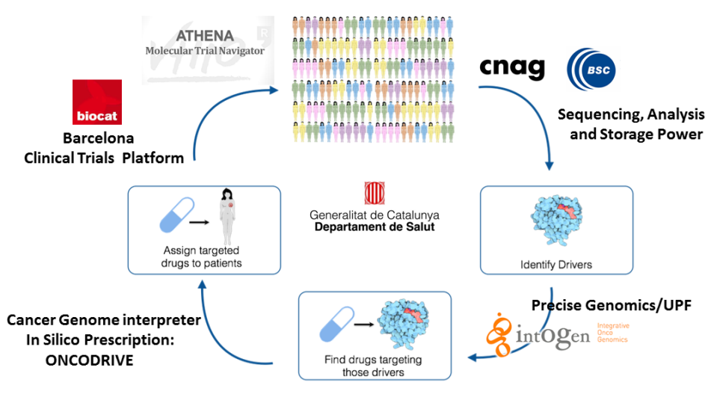
In short, GENPRECIS.CAT works as an interpreter of the Cancer Genome, where the in-put is the somatic mutations of the patient’s tumor and the out-put is a report that defines which driver mutations and which anti-cancer therapies are available (or in development) for that patient.
GENPRECIS.CAT will make possible to address each patient to the best clinical trial treatment or the most appropriate registered drug, in only two weeks. If BCTP succeeds at efficiently funnelling in all tumor samples from the greater Barcelona area into the centralized sequencing and analysis machinery in a way that approximately 50 samples can be run in the same lane, the processing costs per unit (eg. patient) will be very affordable.
In short, our solution involves multi-sector collaborations from genomics labs, supercomputing facilities, university hospitals, and government, in order to incorporate cutting edge technology and increased efficiency in clinical research regulation/administration¹. In this way we foster smart assignment of anti-cancer treatments to patients, either registered drugs or drugs in clinical trials and, as a consequence, patient accrual is enhanced and clinical research is expedited overall.
Budgetwise, the ideation phase of BCTP and its setting up involves costs of 150K € to develop agreements among partners, design the web site, promote the solution within the member hospitals (eg. communication campaigns to all oncologists) and the coordination of works. This phase will be finished in September 2015 and has been funded by Biocat and the Health Department of the government in Catalonia.

The implementation phase has an estimated cost of 700K € divided in several working packages: technology integration across all partners, Pilot Run, and Regulatory/Administrative tasks. The Pilot Run has an estimated time line of 1 year and it will involve all Barcelona patients newly diagnosed in a concrete area of oncology (eg. lung cancer). Afterwards BCTP aims to be expanded to all other oncology areas (eg. colorectal cancer, breast cancer, etc.) and also to other regions, internationally.

¹ References: Dialogues on Diversifying Clinical Trials: Successful Strategies for Engaging Women and Minorities in Clinical Trials: http://www.ncbi.nlm.nih.gov/pmc/articles/PMC3432572/

