ClinicalTrials.gov+Plus: Leveraging the U.S. National Institutes of Health Website to Inform Americans about Clinical Trials that are Important to Them
Proposed Solution: A mobile application that is linked to the largest clinical trial repository in the United States (e.g. clinicaltrials.gov) and is not attached to an institution or company, can be accessed from all platforms (e.g. smartphones, tablets, computers), that will offer the information in a more usable format, tailored to individuals of low literacy as well as low computer literacy, in multiple languages, and which minimizes the cognitive burden on the user (recognizing that most users are under stress and in poor health with low attention span and possible cognitive or reasoning impairments). It will provide direct links with google maps to provide location and direction information. Additionally, it will include sections that allow patients and medical providers to publish crowd-sourced reviews of their participation in the specific clinical trial.
With mobile health use on the rise, many of the estimated 500 million Smartphone users worldwide are low SES populations-- those who are most difficult to recruit into clinical trials. Based on our search of the Apple and Play Store, there are approximately 130 mobile applications that include clinical trial information; however, they are tied to a particular Institution or private company and/or only provide general information. In other words, no mobile application currently exists that is directly affiliated with ClinicalTrials.gov. In addition, the ClincalTrial.gov site, while comprehensive, is complex, and may be difficult to navigate, especially for those of low SES, and patients under emotional and physical stress. Capitalizing and expanding on existing mobile clinical trial applications, we propose to create a mobile application for clinical trials, “ClinicalTrials.gov+Plus” for both iOS and Android platforms (to be sold for $0.99) that is directly linked with the ClinicalTrials.gov website, and will include several innovative, user-friendly features.
How will you do it? We have experience building mobile applications, and will work with TEK Systems to program the application. Raising the initial funds to develop the mobile application will be a major hurdle.
How does it work? The different components of the mobile applications are listed below:
PRELIMINARY SCREENING QUESTIONS AND SEARCH RESULTS
Without having to navigate a complex search process, an initial set of questions will screen for basic information (e.g. age, gender, illness type, location; language preference), and using an algorithm with key search words will allow patients and their families to quickly locate clinical trials that are of interest to them. ClinicalTrials.gov does have basic and advanced search options, but we propose to flip the search from a ‘pull’ to a ‘push’ – meaning that as relevant trials come up, notifications (i.e. text, e-mails) can be sent directly to users.
EDUCATIONAL MODULE FOR PATIENTS AND THEIR FAMILIES
An educational module will provide answers to the following questions:
- Why should I participate? (will emphasize participating for personal reasons and to represent their culture and community)
- What are the different types of clinical trials?
- How does one participate in a clinical trial?
- Who conducts clinical trials and how long do they usually last?
- What are my rights as a clinical trial participant?
- What are the potential risks and benefits? What kinds of questions should I ask?
- Should I expect to be paid? Should I expect to pay?
DESCRIPTION OF EACH TRIAL
From the generated list of clinical trials, the user will then be able to tap of click on the link to get specific information about the trial, including the following:
- Purpose of the trial with detailed descriptions available; Sponsor, Collaborator ;
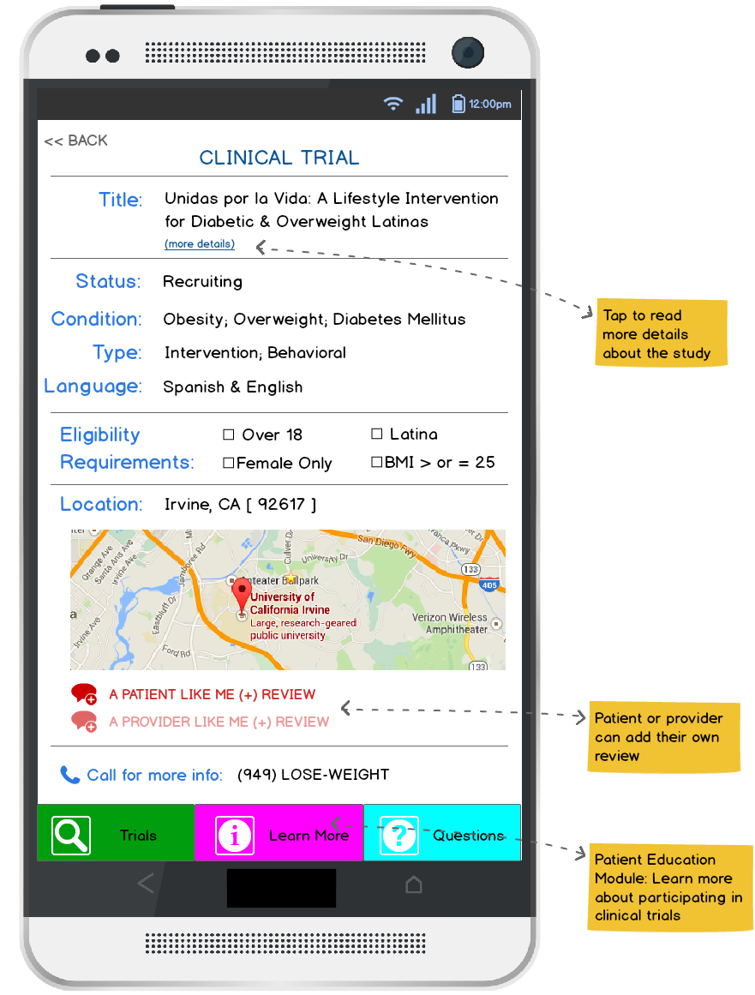
- Study type, study design, eligibility;
- Outcomes (primary and secondary);
- Arms, Assigned Interventions;
- Contacts with ability to provide links to published manuscripts;
- Link to google maps to provide directions to location;
- A PATIENT LIKE ME – a section that allows patients to publish crowd-sourced reviews of their participation in the specific clinical trial;
- A PROVIDER LIKE ME – a section that allows providers (physicians, nurses, researchers) to publish crowd-sourced reviews of their experiences referring patients to the specific clinical trial
How and where will you implement it? Sell it in the App and Play Stores.
Who will be involved/Stakeholders? 1) Faculty at the University of California who bring knowledge of cutting edge innovation to ensure the usability of the site. 2) Partners in businesses (e.g. Google)
How much will it cost? It will cost $350,000 to develop and test an initial version of application that will work on multiple platforms, and an additional $125 to implement ($99/year for Apple Store; $25 one-time fee for Player Store).
How many people will be impacted? The nearly 2 billion smartphone users worldwide. According to the American Cancer Society, in 2015, there will be an estimated 1,658,370 new cancer cases diagnosed in the United States. We expect that within 1-year of the launch of “ClinicalTrials.gov+Plus”, 800,000 (approximately half) people will have downloaded the application. This is a conservative estimate as it does not include patients who already have been diagnosed with cancer or their family members and friends. We anticipate that accrual in cancer clinical trials associated with the University of California (10 Universities across California, 5 with active Medical School enrolling patients in cancer clinical trials) will increase by 50%, and we will be able to track this change by partnering with our sister campuses.
How long will it take to create a proposed solution? 1-year
Why will it work? Why is it viable? It will work because all the pieces are there—there already exists a repository of information – the key is getting it to people in a way that is useful, easily to navigate, and provides a way for users to interact with, and share information with, other users like them.
Sustainability of Solution: Form partnership with US government and/or groups engaged in clinical research to provide continued financial support to maintain and develop the application.
Regulatory Hurdles: None
Why hasn’t it been tried before/Why will it work: It hasn’t been tried before because private companies do not see the market value of developing such an application (because it is a U.S. government site), and the U.S. government has already fulfilled their obligation to provide this information (through the website). However, individual users may be willing to pay the $0.99 for access to this up-graded information.

