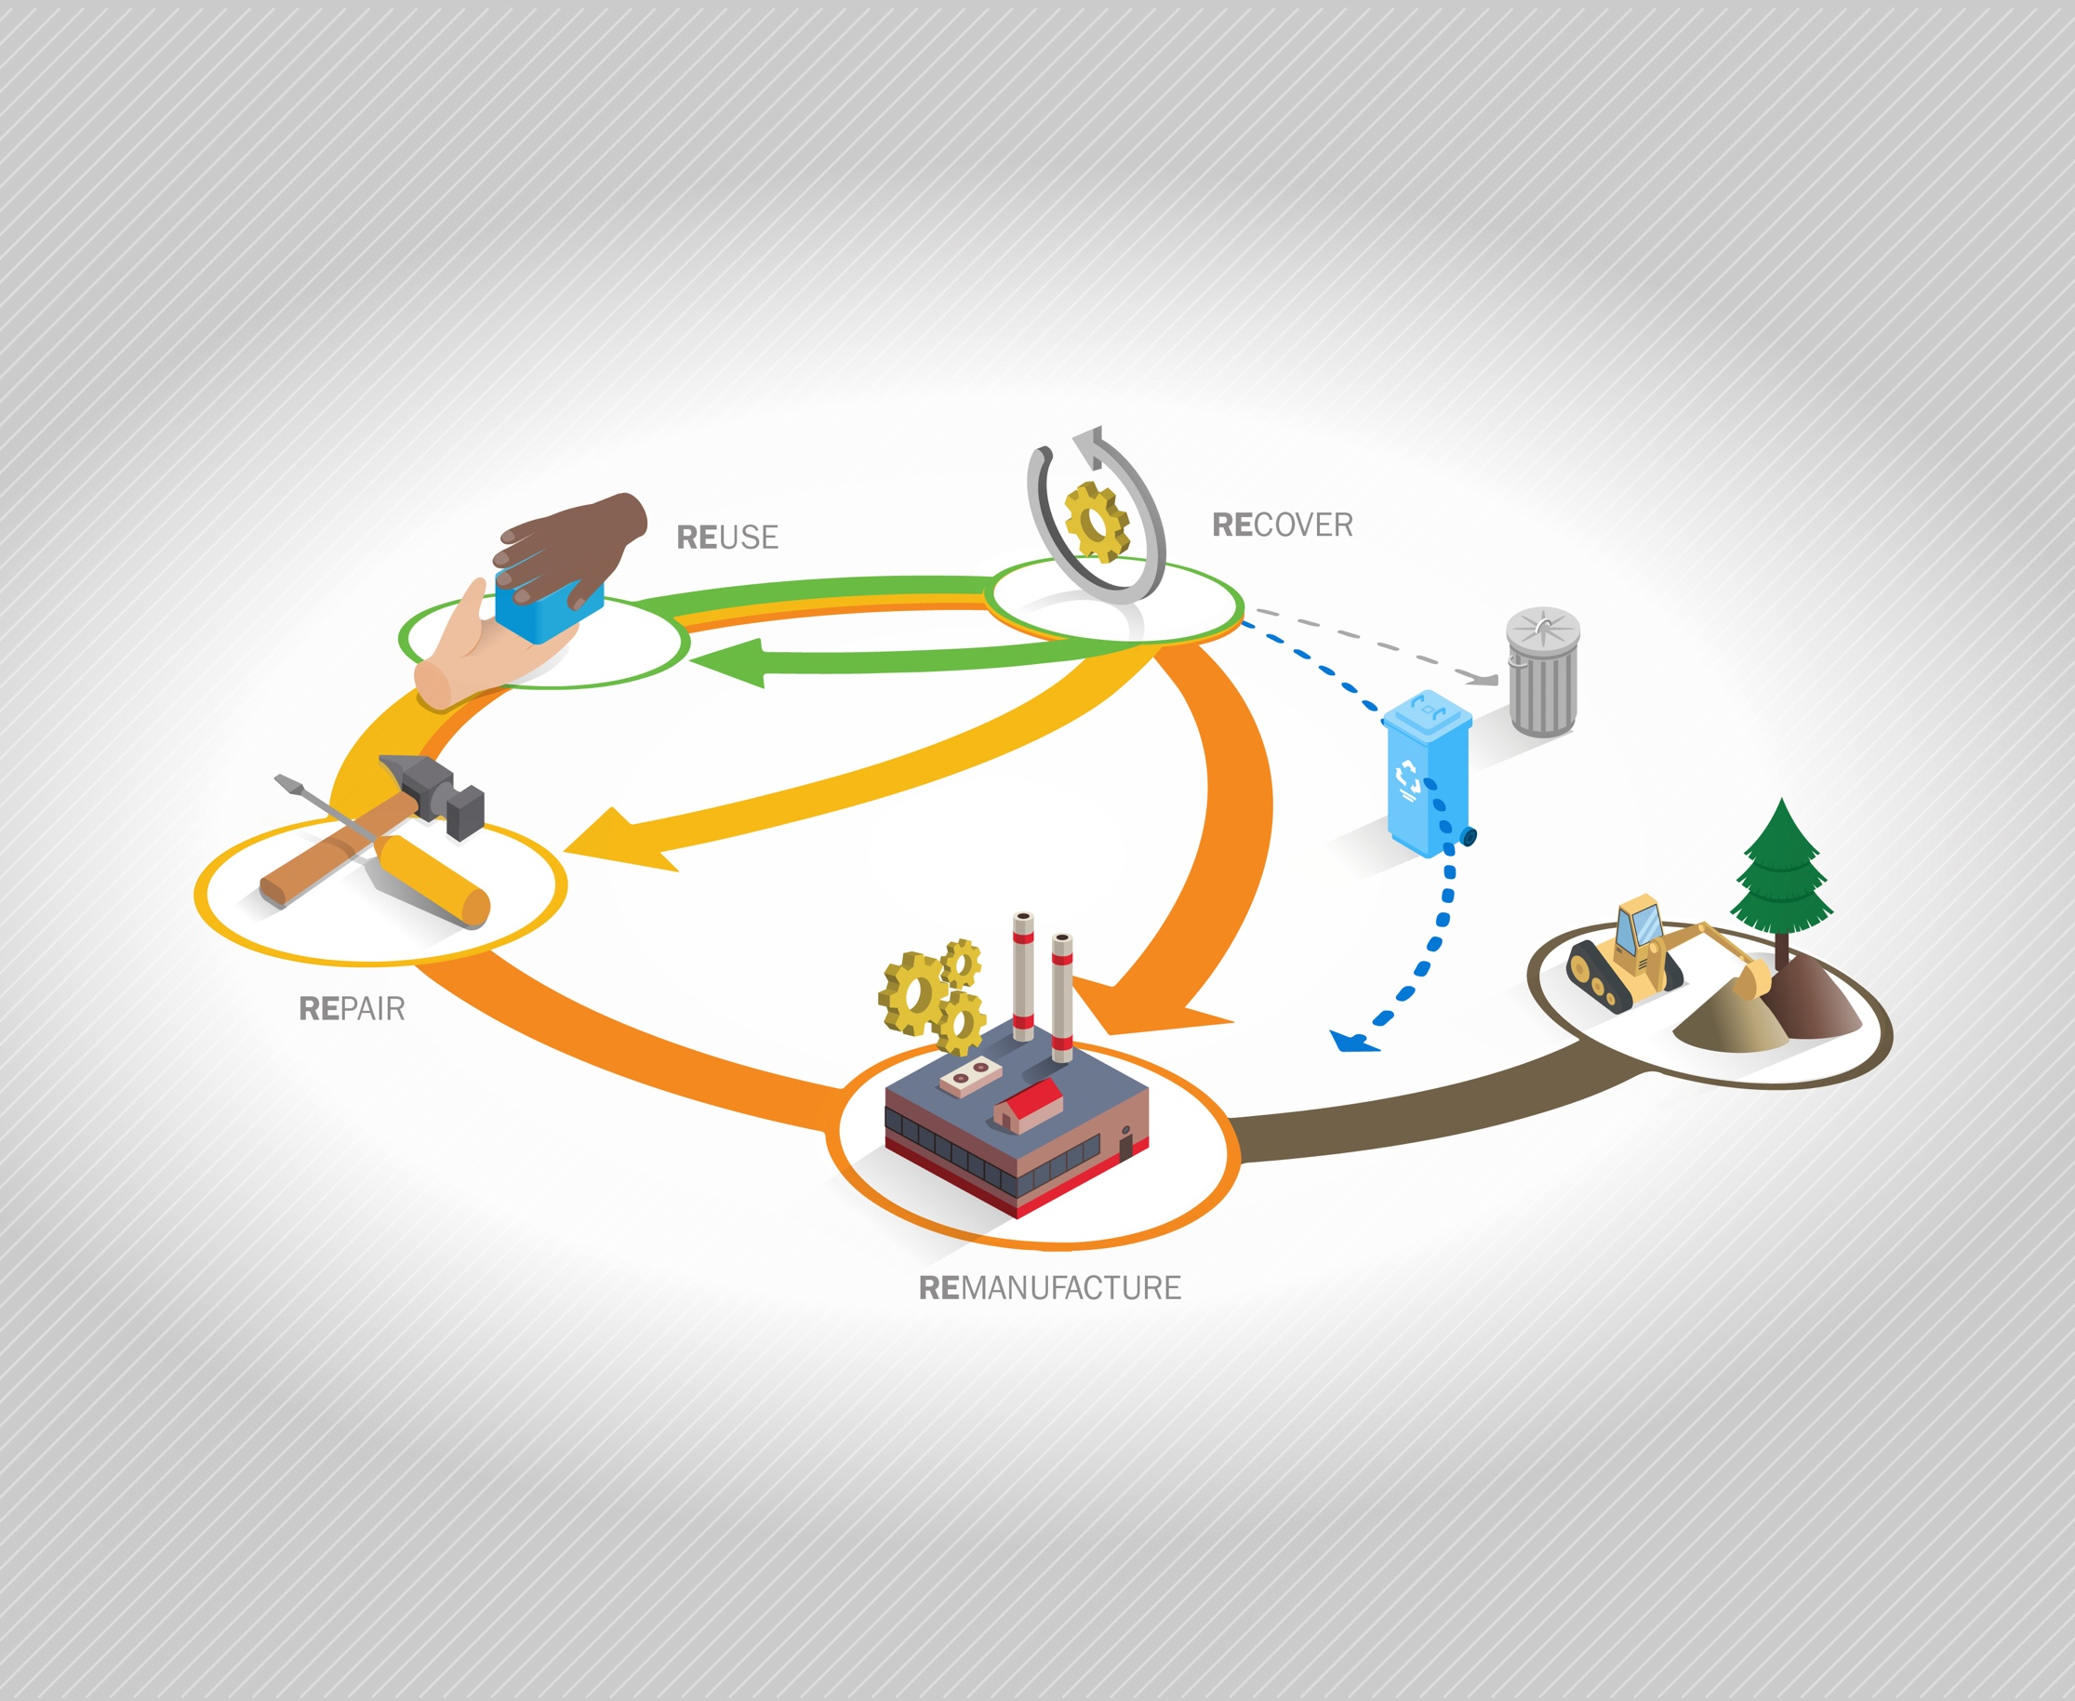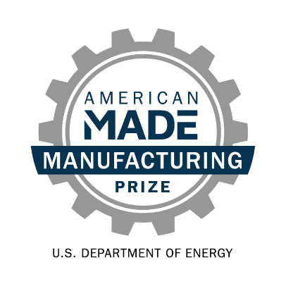

**Re-X Before Recycling Prize   
Phase 1: *Identify!*  
Narrative Template**

# Team Name: (Team Name)

# Five Question Written Narrative Instructions

Answer each of the following five questions:

1. **Opportunity** – What is the opportunity and why is it impactful?
2. **Innovation** – What is your innovation and why will it be successful?
3. **Accomplishments and Team** –Does your team have the knowledge and experience to be successful? What have you accomplished to date?
4. **Plan** – What is your plan to implement the innovation in a new or expanded Re-X supply chain?
5. **Community Benefits Plan** – What community benefits would this new or expanded Re-X supply chain bring?

For convenience, these questions are provided in the headings of the tables on pages 2-6 along with suggested content (and corresponding judging statements) to help guide your responses. You decide where to focus your answers.

You should answer each of the questions in the five areas listed below. The content bullets are only suggestions to guide your responses; you decide where to focus your answers. The individual answers to the five areas do not have a word limit; however, the aggregate response to these five areas must not exceed 2,500 words, not including captions, images, figures/graphs, and references. A word count must be included at the end of your submission. You may also include up to five supporting images, figures, or graphs. The reviewers will score the questions based on the content you have provided.

|  |  |  |
| --- | --- | --- |
| **Topic and Percent of Score** | **Suggested Content to Include** | **What the Score Will Be Based On** |
| **Question 1:** ***Opportunity***  What is the opportunity and why is it impactful?  This section is 20% weight of your total score. | * Describe the Re-X supply chain opportunity. Be specific about the opportunity space that your supply chain addresses. * Explain why this opportunity has not yet been realized and why now is the right time to address it. Describe how it can become an economically viable supply chain. * Show how you know this is a significant opportunity using evidence-based validation (e.g., interviews, case studies, literature). Provide detail on the estimates of waste stream size and availability, interventions needed, end markets, and type and scale of expected impacts (life cycle greenhouse gas or other emissions, product life extension, jobs, etc.). Ensure assumptions are as reasonable as possible. | * The competitor identifies and explains clearly an opportunity for a new or expanded Re-X supply chain that, if realized, will deliver substantial environmental and economic benefits across supply chains at a national scope. * The competitor demonstrates an understanding of the opportunity, relevant industrial ecosystem, and why it has not yet been realized. * The competitor uses real-world evidence to validate key assumptions about the potential environmental, community, and economic impacts of realizing this supply chain. The competitor demonstrates insight into the full supply chain (waste stream, processes needed, end markets) as well as provides estimates of expected impacts based on reasonable assumptions. |

**Response to Question 1:**

|  |  |  |
| --- | --- | --- |
| **Topic and Percent of Score** | **Suggested Content to Include** | **What the Score Will Be Based On** |
| **Question 2:** ***Innovation***  What is your innovation and why will it be successful?  This section is 20% weight of your total score | * Thoroughly describe your innovation concept and how it advances the status quo. * Describe your innovation’s value proposition and how it will lead to a viable Re-X supply chain. Does it save money, increase effectiveness, or provide other benefits? * Provide details on anticipated challenges to successfully realizing the supply chain opportunity and how these challenges can be overcome by this innovation. | * Sufficient detail was provided to understand the proposed innovation. * The competitor has identified a compelling innovation that is differentiated from the status quo and that is likely to lead to a viable Re-X supply chain. * The competitor demonstrates insight into the challenges and provides compelling reasoning as to why the innovation has the potential to overcome the challenges. |

**Response to Question 2:**

|  |  |  |
| --- | --- | --- |
| **Topic and Percent of Score** | **Suggested Content to Include** | **What the Score Will Be Based On** |
| **Question 3:** ***Accomplishments and Team***  Does your team have the knowledge and experience to be successful? What have you accomplished to date?  This section is 20% weight of your total score. | * Introduce your team. Highlight knowledge and skills that make your team capable of realizing the innovation. * Describe your team’s readiness to meet your goals and whether your team requires additional talent and/or resources. * What experience do you have trying new things, solving difficult problems, and overcoming barriers to bring ideas to reality? Highlight your team’s diversity. * Describe your efforts to advance your innovation prior to or after the announcement of this Prize phase. Highlight key learnings and achievements. | * The team demonstrates entrepreneurial qualities such as adaptability, creativity, decisiveness, and resourcefulness. The team is diverse and has the knowledge, experience, and determination to realize the innovation and/or has identified gaps in resources to be addressed. * A considerable amount of high-quality effort was put into defining the opportunity and advancing the innovation concept. |

**Response to Question 3:**

|  |  |  |
| --- | --- | --- |
| **Topic and Percent of Score** | **Suggested Content to Include** | **What the Score Will Be Based On** |
| **Question 4:** ***Plan***  What is your plan to implement the innovation in a new or expanded Re-X supply chain?  This section is 20% weight of your total score. | * Describe where you stand in your innovation’s development cycle and develop a plan with SMART[1] goals to advance your innovation from the current state toward implementation in a viable supply chain. * Describe your team’s proposed metrics that will be used to determine success. See Appendix C for example metrics. * Describe risks and mitigation strategies to address them. * Describe any analysis, such as LCA or TEA, that has been done and how working with a national lab to perform analysis will help you be successful with your innovation. | * The stated goals are ambitious and show commitment to an accelerated development timeline. Meeting them will demonstrate critical progress toward implementing the innovation. * The proposed metrics are clear, ambitious while being achievable, and well defined. * Risks and mitigation strategies have been described. * The team identifies how analysis will help them gain insights to inform design improvements, increasing the innovation’s impact in a viable supply chain. |

**Response to Question 4:**

|  |  |  |
| --- | --- | --- |
| **Topic and Percent of Score** | **Suggested Content to Include** | **What the Score Will Be Based On** |
| **Question 5:** ***Community Benefits* Plan**  What community benefits would this new or expanded Re-X supply chain bring?  This section is 10% weight of your total score. | * Identify communities the supply chain will affect. Describe the challenges or problems the communities are facing and the benefit your proposed innovation will foster. * Describe the specific strategies and activities that you plan to use to engage, educate, gain trust, and obtain buy-in from these communities. * Include at least one SMART goal addressing DEIA, workforce implications, or environmental justice. | * The competitor demonstrates insight into the impact of the Re-X supply chain on disadvantaged, underserved, and/or marginalized communities. This includes environmental and economic benefits, hazards, and workforce implications. * The approach to community benefits describes at least one measurable goal with concrete actions, is strong, and is likely to be successful. |

**Response to Question 5:**

## Five question narrative word count: _______ total words

**Please read and comply with submission requirements in the** [**Official Rules**](https://www.herox.com/ReXBeforeRecycling/resource/1558)**.**

**COMPETITORS THAT DO NOT COMPLY WITH THESE REQUIREMENTS MAY BE DISQUALIFIED.**

1. A SMART action plan incorporates five characteristics of a goal: specific, measurable, attainable, relevant, and time-based. For more information about SMART goal planning, see: <https://www.atlassian.com/blog/productivity/how-to-write-smart-goals>.