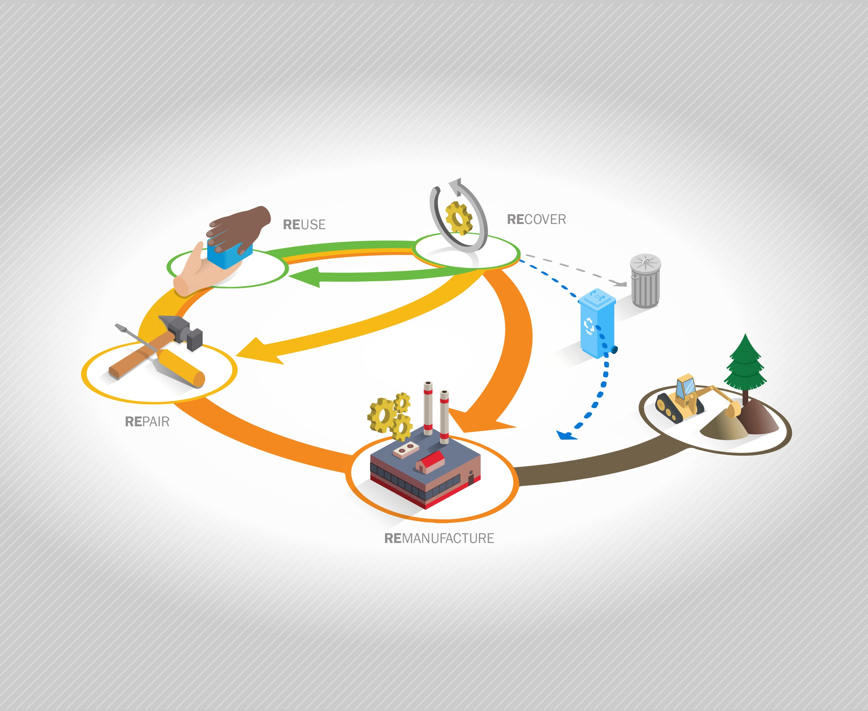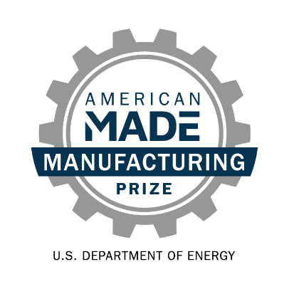

**Re-X Before Recycling Prize   
Phase 2: *Prepare!*  
Narrative Template**

# Team Name: (Team Name)

# Five Question Written Narrative Instructions

Answer each of the following five questions:

1. **Opportunity** **& Innovation** – How does your innovation advance a Re-X supply chain and what benefits will it bring?
2. **Team** – Does your team have the knowledge and experience to be successful? If additional capabilities are needed, how will they be filled?
3. **Progress** – How have you advanced your innovation since the launch of the prize?
4. **Plan** – What is your plan to achieve your goals?
5. **Community Benefits Plan** – What community benefits would implementing your innovation in a Re-X supply chain bring? What is your plan to maximize them?

For convenience, these questions are provided in the headings of the tables on pages 2-6 along with suggested content (and corresponding judging statements) to help guide your responses. You decide where to focus your answers.

You should answer each of the questions in the five areas listed below. The content bullets are only suggestions to guide your responses; you decide where to focus your answers. The individual answers to the five areas do not have a word limit; however, the aggregate response to these five areas must not exceed 5,000 words, not including captions, images, figures/graphs, and references. A word count must be included at the end of your submission. You may also include up to five supporting images, figures, or graphs. The reviewers will score the questions based on the content you have provided.

|  |  |  |
| --- | --- | --- |
| **Topic and Percent of Score** | **Suggested Content to Include** | **What the Score Will Be Based On** |
| **Question 1:** ***Opportunity & Innovation***  How does your innovation advance a Re-X supply chain and what benefits will it bring?  This section is 25% weight of your total score. | * Describe your innovation, its value proposition, how it will enable a new or expanded viable Re-X supply chain, the benefits of the supply chain, anticipated challenges, and how the challenges can be overcome. Explain how your concept for the innovation has evolved. * Show how you know this is a significant opportunity using evidence-based validation (e.g., interviews, case studies, literature). Describe how the activities during the prize have informed your understanding of the significance of realizing this opportunity. Incorporate relevant insights from national lab analysis consulting, if applicable. * Provide estimates of waste stream size and availability, interventions needed, end markets, and type and scale of expected impacts (life cycle greenhouse gasses or other emissions, product life extension, jobs, etc.). Ensure assumptions are as reasonable as possible. | * The competitor clearly explains the innovation, why it would represent significant process toward a viable Re-X supply chain, and how their concept has evolved during the prize. * The competitor demonstrates understanding of the key challenges to be overcome and provides compelling reasoning and evidence that the innovation has potential to overcome the challenges. * The competitor has substantially refined their understanding of the significance of the Re-X opportunity using real-world evidence to validate key assumptions. * The competitor provides quantitative estimates of expected environmental and economic impacts based on reasonable assumptions and informed by deepening insight into waste stream, processes needed, end markets. |

**Response to Question 1:**

|  |  |  |
| --- | --- | --- |
| **Topic and Percent of Score** | **Suggested Content to Include** | **What the Score Will Be Based On** |
| **Question 2: *Team***  Does your team have the knowledge and experience to be successful? If additional capabilities are needed, how will they be filled?  This section is 15% weight of your total score. | * Introduce your team. Highlight knowledge and skills that make it capable of achieving your goals. * Describe how you have activated your network of mentors and partners and how they will help you be successful. Highlight how your team has evolved, including any strategic hires or partnerships. * Include any letters of intent/support. | * The team’s drive, diversity, knowledge, and experience provides a strong competitive edge toward realizing this innovation in the near future. * The team identified gaps in talents and resources and brought in the right people or partners to fill those gaps. * The team has activated a network of mentors and partners that increases the team’s chances of implementing the innovation in a viable supply chain. |

**Response to Question 2:**

|  |  |  |
| --- | --- | --- |
| **Topic and Percent of Score** | **Suggested Content to Include** | **What the Score Will Be Based On** |
| **Question 3: Progress**  How have you advanced your innovation since the launch of the prize?  This section is 25% weight of your total score. | * Describe the progress made to advance your innovation since the launch of the Prize[1]. Highlight key insights gained, relationships or partnerships formed, and milestones achieved. * Summarize challenges identified and what has been done to overcome them. * Provide a timeline and milestones for advancing the innovation and describe outcomes to date. | * The competitors are successfully meeting goals, overcoming challenges, and demonstrating continued critical progress toward advancing their innovation. * A considerable amount of high-quality effort was put into deepening insight and developing partnerships to advance the innovation and realize the Re-X supply chain opportunity since the launch of the Prize. |

**Response to Question 3:**

|  |  |  |
| --- | --- | --- |
| **Topic and Percent of Score** | **Suggested Content to Include** | **What the Score Will Be Based On** |
| **Question 4:** ***Plan***  What is your plan to achieve your goals?  This section is 15% weight of your total score. | * Provide a detailed plan with SMART[2] goals for advancing your innovation from the current state toward implementation in a viable Re-X supply chain. *Phase 1: Identify!* Competitors can revise their previous plan. Include the metrics that will be used to determine success. * Describe the risks to the plan to advance your innovation and mitigation strategies to address them. * Describe the LCA, TEA, or other analysis that a national laboratory will perform during *Phase 3: Develop!* To assess the potential impact of your innovation and opportunities to improve it and/or increase the impact. What insights do you expect to gain and how will you incorporate them into your plan? How has insights from national lab analysis consultation been incorporated into your understanding, if applicable? | * The stated goals are ambitious, address risks, and show commitment to an accelerated implementation timeline. Meeting the stated goals will demonstrate critical progress toward implementing the innovation in a viable Re-X supply chain. * The approach to complete the plan is well-reasoned and makes good use of the resources available. * Sufficient risks to the development plan have been identified and reasonable mitigation strategies have been described. * The team describes what national lab analysis will provide insights to improve their innovation and increase impact. The proposed analysis makes sense, is likely to provide insights to improve their innovation and impact, and the competitor is poised to incorporate those insights into future plans. |

**Response to Question 4:**

|  |  |  |
| --- | --- | --- |
| **Topic and Percent of Score** | **Suggested Content to Include** | **What the Score Will Be Based On** |
| **Question 5:** ***Community Benefits Plan***  What community benefits would implementing your innovation in a Re-X supply chain bring? What is your plan to maximize them?  This section is 10% weight of your total score. | * Describe the impact of your innovation and Re-X supply chain on communities and how your understanding has evolved over the prize. * Describe how the innovation will advance DEIA, workforce development, and environmental justice in these communities. Include at least one SMART goal to advance at least one of these aspects. * Describe progress made in engaging, educating, gaining trust, or obtaining buy-in from the targeted communities. Include challenges or barriers identified and how you plan to continue to engage these communities. | * The competitor demonstrates deepening insight into the impact of the proposed supply chain on communities. * The approach to community engagement describes concrete actions, is strong, and progress has been demonstrated. * The competitor has identified at least one SMART goal to advance DEIA, work force, or environmental justice. |

**Response to Question 5:**

## Five question narrative word count: _______ total words

**Please read and comply with submission requirements in the** [**Official Rules**](https://www.herox.com/ReXBeforeRecycling/resource/1558)**.**

**COMPETITORS THAT DO NOT COMPLY WITH THESE REQUIREMENTS MAY BE DISQUALIFIED.**

1. The Re-X Before Recycling Prize was launched on November 24, 2023.
2. A SMART action plan incorporates five characteristics of a goal: specific, measurable, attainable, relevant, and time-based. For more information about SMART goal planning, see: <https://www.atlassian.com/blog/productivity/how-to-write-smart-goals>. Each SMART goal should have all elements (specific, measurable, attainable, relevant, and time-based) identified.