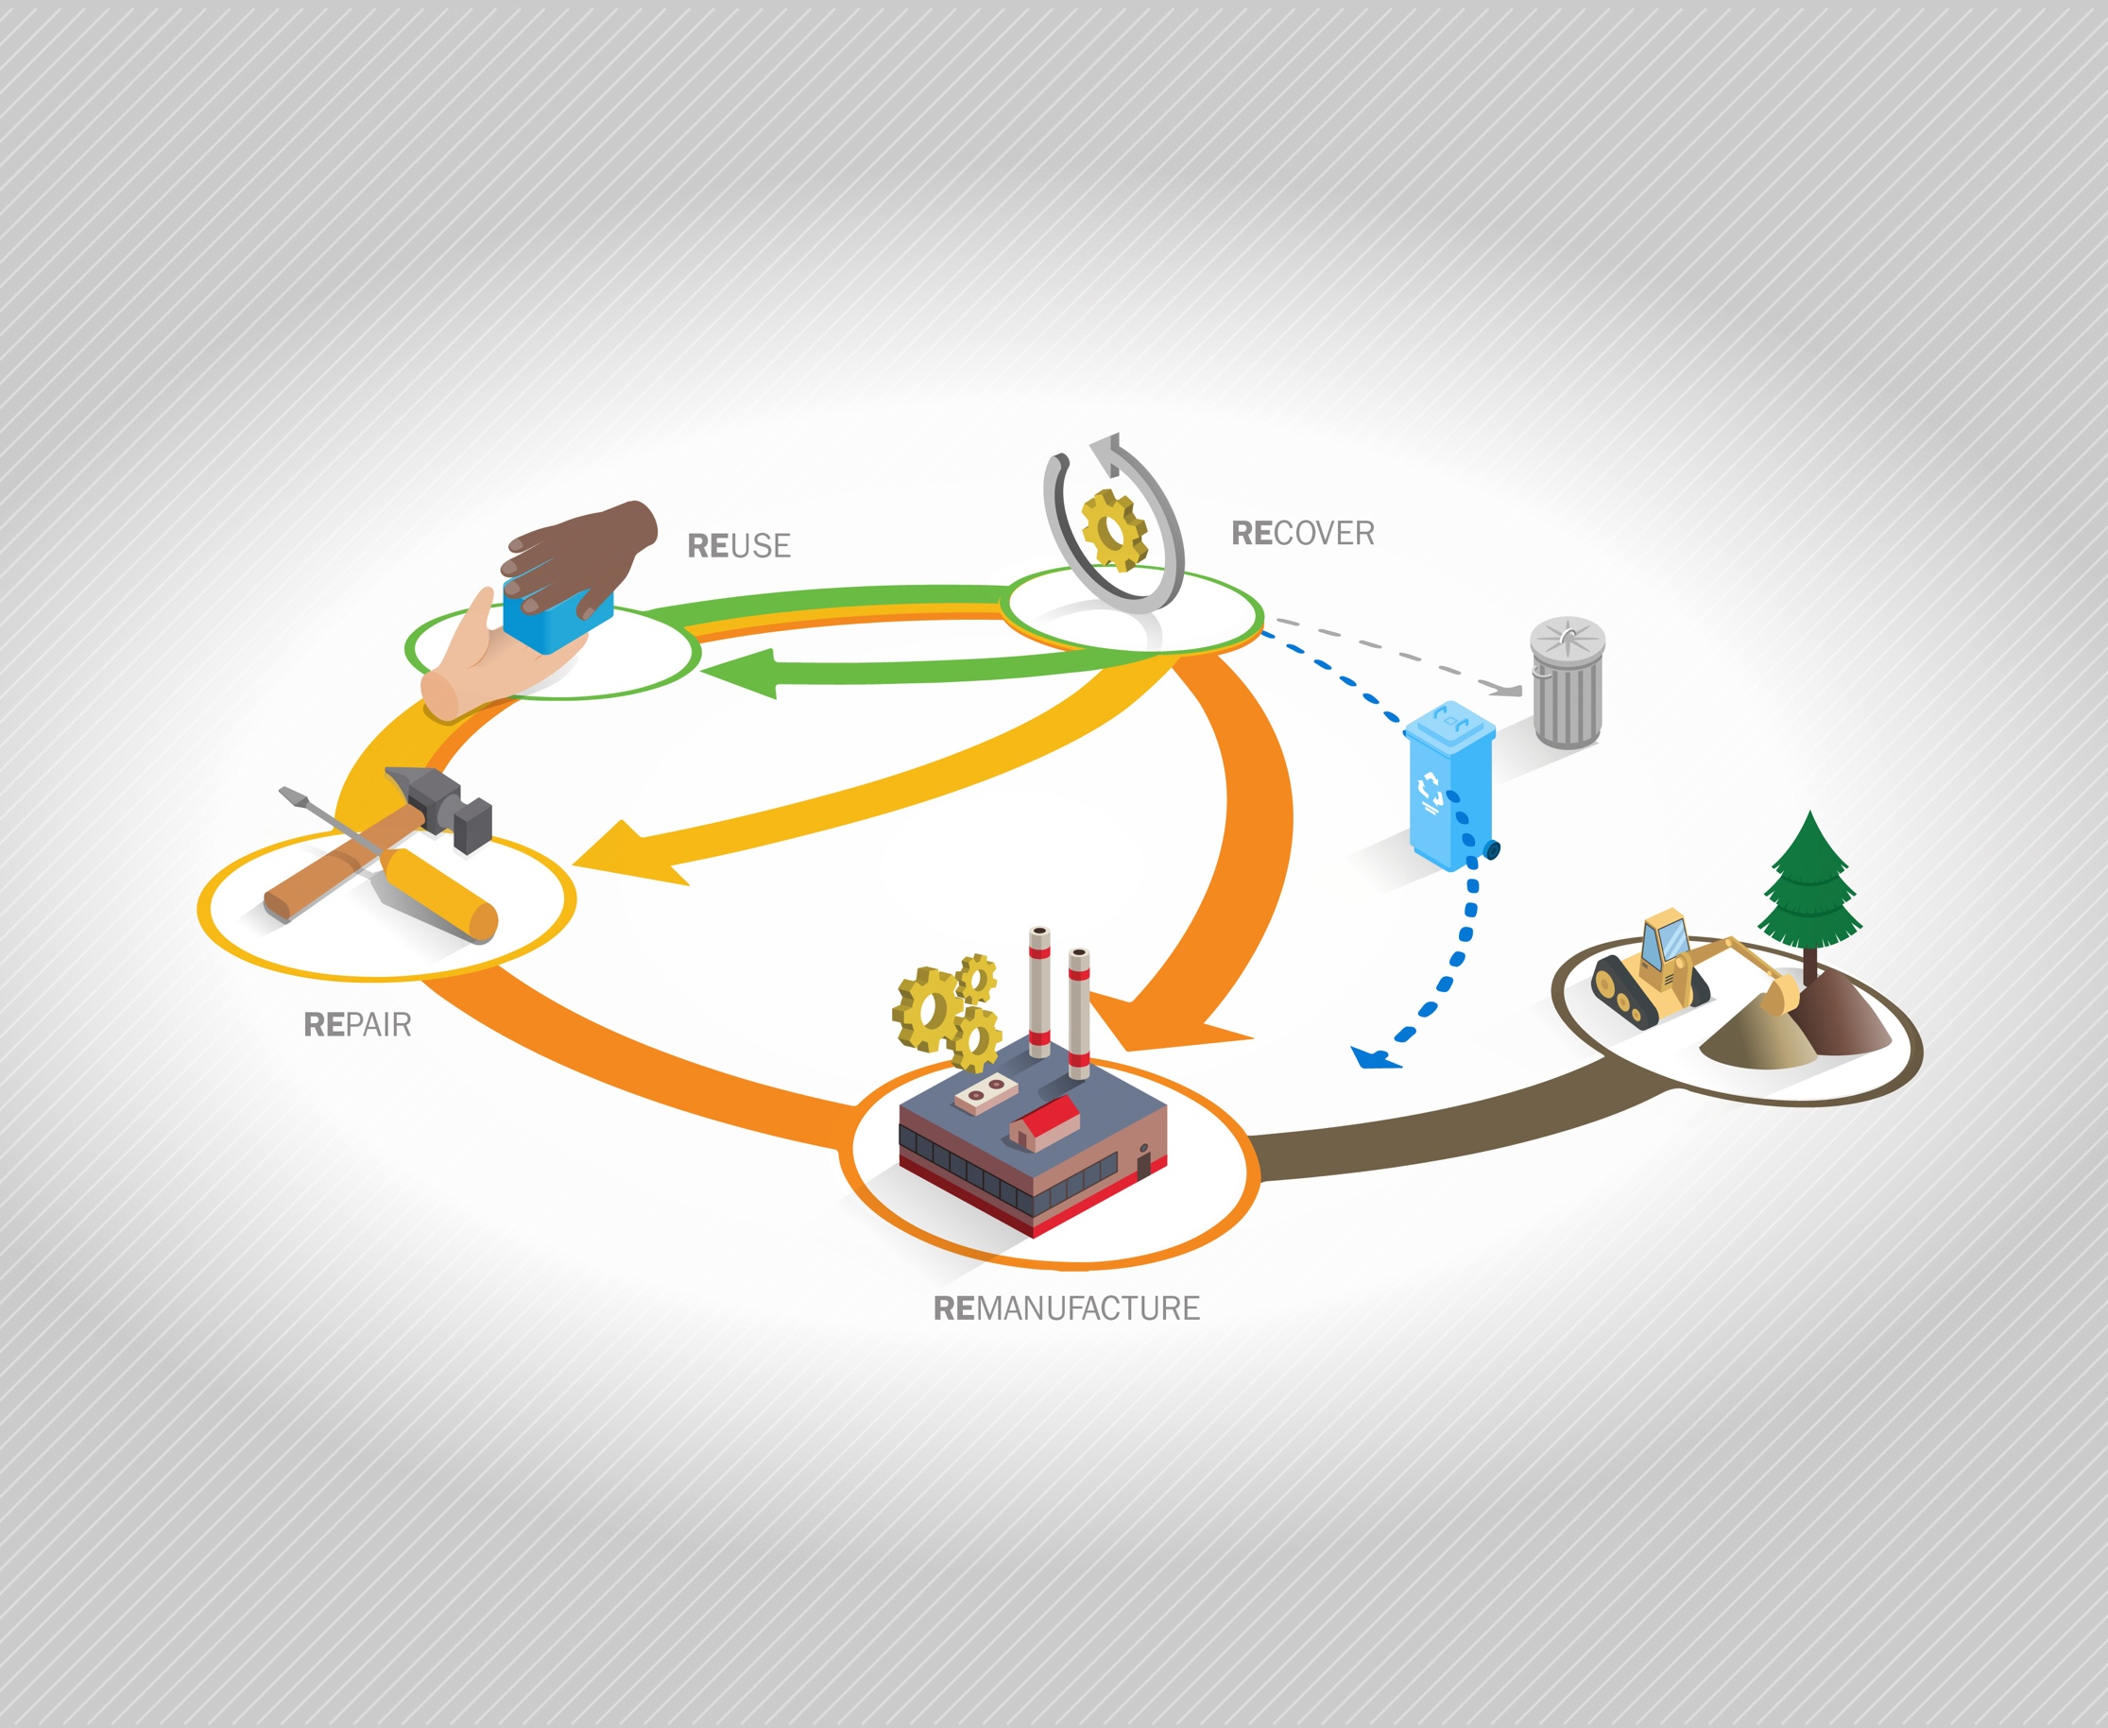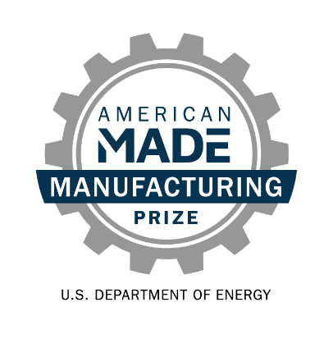

**Re-X Before Recycling Prize   
Phase 3: *Develop!*Narrative Template**

# Team Name: (Team Name)

# Five Question Written Narrative Instructions

Answer each of the following five questions:

1. **Opportunity** **& Innovation** – How does your innovation advance a Re-X supply chain and what benefits will it bring?
2. **Team** – Going forward, does your team have the knowledge and experience to be successful? How have you grown?
3. **Progress** – What progress have you made to advance your innovation and prove it will be successful?
4. **Post-Prize Plan –** What is your plan to achieve your goals post-prize?
5. **Community Benefits Plan** – What community benefits would implementing your innovation in a Re-X supply chain bring and how are you working to maximize them?

For convenience, these questions are provided in the headings of the tables on pages 2-6 along with suggested content (and corresponding judging statements) to help guide your responses. You decide where to focus your answers.

You should answer each of the questions in the five areas listed below. The content bullets are only suggestions to guide your responses; you decide where to focus your answers. The individual answers to the five areas do not have a word limit; however, the aggregate response to these five areas must not exceed 7,500 words, not including captions, images, figures/graphs, and references. A word count must be included at the end of your submission. You may also include up to eight supporting images, figures, or graphs. The reviewers will score the questions based on the content you have provided.

|  |  |  |
| --- | --- | --- |
| **Topic and Percent of Score** | **Suggested Content to Include** | **What the Score Will Be Based On** |
| **Question 1:** **Opportunity & Innovation**  How does your innovation advance a Re-X supply chain and what benefits will it bring?  This section is 30% weight of your total score. | * Describe your innovation, its value proposition, how it advances the status quo, anticipated challenges, and how the challenges can be overcome. Explain how your innovation has evolved during the prize. * Show how you know this is a significant opportunity using evidence-based validation. Describe how the activities during the prize have informed your understanding of the significance of realizing this Re-X supply chain opportunity. * Provide revised estimates of waste stream size and availability, interventions needed, end markets, and type and scale of expected impacts (life cycle greenhouse gasses or other emissions, product life extension, jobs, etc.). Incorporate insights from analysis and other activities during the prize. | * The competitor clearly explains their supply chain innovation, how it advances the status quo, why it would represent significant progress, and how it has developed during the prize. * The competitor has identified a compelling innovation, demonstrates understanding of the key challenges to be overcome, and provides compelling reasoning and evidence that the innovation has potential to overcome the challenges. * The competitor demonstrates substantial refinement of their understanding of the significance of their innovation and the supply chain it enables using real-world evidence to validate key assumptions. * The competitor provides revised quantitative estimates of expected environmental and economic impacts based on reasonable assumptions and informed by deep sight into waste stream, processes needed, and end markets. |

**Response to Question 1:**

|  |  |  |
| --- | --- | --- |
| **Topic and Percent of Score** | **Suggested Content to Include** | **What the Score Will Be Based On** |
| **Question 2: *Team***  Going forward, does your team have the knowledge and experience to be successful? How have you grown?  This section is 15% weight of your total score. | * Re-Introduce your team. Highlight knowledge and skills that make it capable of achieving your goals and implementing your innovation. * Describe how you have developed ecosystem partnerships and how your team has evolved. Provide detail on how these partnerships will help you be successful. Include at least one letter of commitment partnership or support. | * The team demonstrates the passion, skills, commitment, and diversity needed to realize their supply chain innovation in the near future. * The team identified gaps in talents and resources and brought in the right people or partners to fill those gaps. * The team’s ecosystem partnerships demonstrate their ability to implement their supply chain innovation. They have submitted at least one letter of committed partnership or support. |

**Response to Question 2:**

|  |  |  |
| --- | --- | --- |
| **Topic and Percent of Score** | **Suggested Content to Include** | **What the Score Will Be Based On** |
| **Question 3: Progress**  What progress have you made to advance your innovation and prove it will be successful?  This section is 15% weight of your total score. | * Describe the progress you made during the prize. Highlight key insights you have gained, relationships or partnerships you have formed, and milestones you have achieved. * Summarize the challenges that have occurred and what has been done to overcome them. * Provide the goals from your *Phase 2: Prepare!* submission package and describe the actual outcomes. * Comment on any adaption of the goals you have made to be more impactful based on deepening your understanding gained during prize. | * The competitor is successfully meeting prior goals, overcoming challenges, and demonstrating continued critical progress toward advancing their innovation. * The competitor has adapted their goals and plan to make their innovation more impactful based on their deepening understanding. * A considerable amount of high-quality effort was put into advancing the innovation and developing partnerships. |

**Response to Question 3:**

|  |  |  |
| --- | --- | --- |
| **Topic and Percent of Score** | **Suggested Content to Include** | **What the Score Will Be Based On** |
| **Question 4:** **Post-Prize Plan**  What is your plan to achieve your goals post-prize?  This section is 20% weight of your total score. | * Describe your business model/plan post-prize. * How will you ensure you have the support post- prize to continue advancing your innovation towards a viable supply chain? * What challenges do you foresee post-prize and how will you address them? * Describe how you plan to incorporate insights from the national lab analysis to improve your innovation and/or understand impacts of the Re-X supply chain. Describe any changes you have made as a result of insights from the analysis. | * The approach to implement the innovation in a viable supply chain beyond this prize is well-reasoned and feasible. * Metrics to measure progress have been identified and are appropriate. * Largest risks to the development plan have been sufficiently identified and reasonable mitigation strategies have been described. * Insights from national lab supported analysis have been integrated into the team’s understanding and their approach to advancing the innovation. |

**Response to Question 4:**

|  |  |  |
| --- | --- | --- |
| **Topic and Percent of Score** | **Suggested Content to Include** | **What the Score Will Be Based On** |
| **Question 5:** ***Community Benefits Plan***  What community benefits would implementing your innovation in a Re-X supply chain bring and how are you working to maximize them?  This section is 10% weight of your total score. | * How has your understanding of and approach to community benefits evolved over the prize? * What have you achieved to realize community benefits? Describe actual outcomes of your goals. * What is your actionable plan to maximize community benefits as you continue to advance your innovation post-prize? | * The competitor demonstrates deepening insight into the impact of the proposed supply chain on communities. * The competitor demonstrates progress realizing their community benefits goals. * The post-prize plan to maximize community benefits is actionable, strong, and likely to succeed. |

**Response to Question 5:**

## Five question narrative word count: _______ total words

**Please read and comply with submission requirements in the** [**Official Rules**](https://www.herox.com/ReXBeforeRecycling/resource/1558)**.**

**COMPETITORS THAT DO NOT COMPLY WITH THESE REQUIREMENTS MAY BE DISQUALIFIED.**