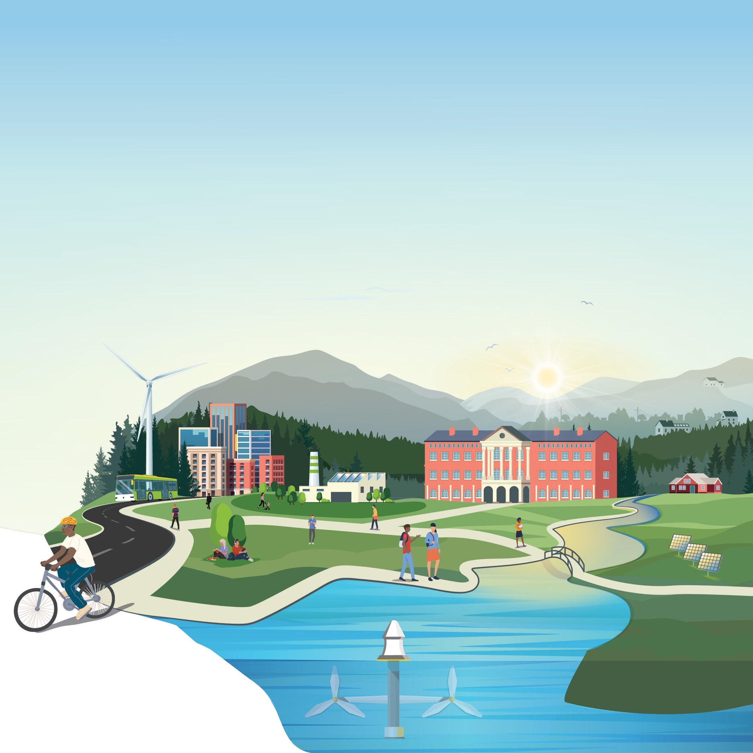
[Official Team Name]
PROGRESS Phase – Submission Template
Community Energy Innovation Prize
Teams must produce a Progress Report using this template which summarizes the accomplishments to-date that demonstrate continued engagement and project development. Suggested content for the Progress Report is further detailed in the rules alongside scoring criteria.

The total length of the report should not exceed 1,500 words. Titles, headings, subheadings, footnotes, a short description, and the list of team members/partners do not count toward the 1,500-word limit. Competitors may include up to five supporting visualizations, tables, or graphics. If a competitor chooses to include a budget, that will not count toward the five supporting visualizations. The report must be submitted as a PDF via the HeroX platform along with the other submission documents. Information contained in hyperlinks to external sources will not be reviewed or considered by the reviewers or the Judge.

The Progress Report must be submitted as a PDF with the Evidence of Progress and Evidence of Commitment via the HeroX platform.
Competitors should address the Prize Objectives in the Official Rules Document.
Use of this template is optional.
** PLEASE DELETE THIS TEXTBOX FROM YOUR FINAL SUBMISSION **

[Please delete bracketed guidance text prior to submission]

1 Team Information
[Fill in the information below for each team member. The first team member listed should be the Team Lead. Does not count towards 1500-word limit.]
Student Team Member Name | Grade Level | Major/Minors
[first, last] | Ex: Graduate | Ex: Environmental Science
[first, last]
[first, last]

2 Community Partner
[Fill in the information below for each community partner. Does not count towards 1500-word limit.]
Community Partner | Roles / Responsibilities in Project Implementation to Date and Moving Forward in the Prize
[Title]
[Title]
[Title]

3 Faculty Advisors
[Fill in the information below for each community partner. Does not count towards 1500-word limit.]
Faculty Advisors | Roles / Responsibilities in Project Implementation to Date and Moving Forward in the Prize
[Title]
[Title]
[Title]

4 Short Description
[A brief overview of the project and status of the project. Recommended length: 50-200 words, does not count towards 1500-word limit.]

5 Explanation of Resources
[Explanation for what resources are being and will be utilized to implement the project, including the student team, the Academic Institution, the Community Partner, and any other contributing local organizations.]

6 Progress of Planned Implementation
[Progress of the implementation of the planned outreach and engagement activities and strategies that have been and will be used to engage the broader community.]

7 Challenges Encountered
[Challenges encountered to date and/or anticipated future challenges from implementation of the project and mitigation strategies to address them.]

8 Adherences or Changes
[Adherence or changes made to the initially identified schedule and specific
metrics, milestones, and other measurements of success the team achieved to date.]

Evidence of Progress
[Teams must submit evidence of progress on their accomplishments to date. Content for the
Evidence of Progress may include but is not limited to the following examples: marketing materials, social media posts, website development or improvements, curriculum, training materials, new subscribers or signups related to project, informational presentations and slide decks, etc.]

Evidence of Commitment
[Teams should upload an Evidence of Commitment as a single file, combining documents from the Faculty Advisor from the Academic Institution and the Community Partner(s) with which the student team is partnering. This evidence may be represented through letters of commitment, memoranda of
understanding, contracts, and/or funding agreements.]

