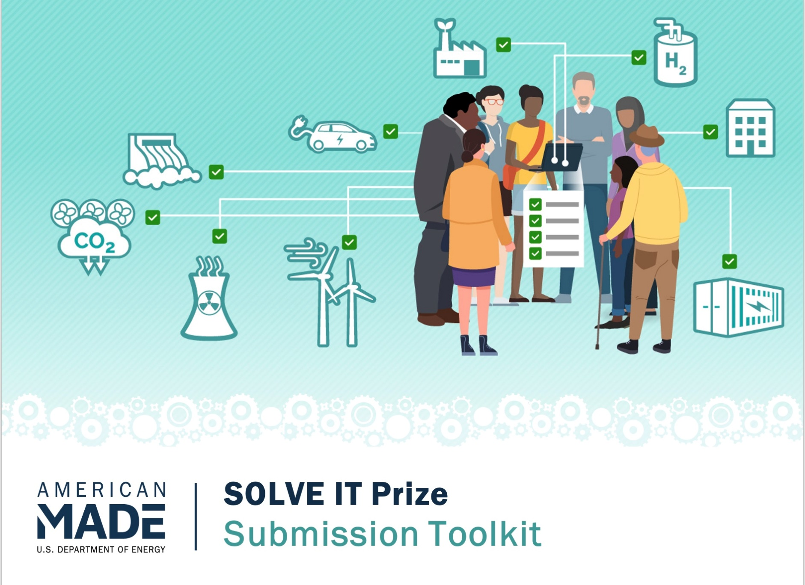**COVER PAGE**

*Please fill out the sections below. You can also design your own cover page—just remember to include all the sections listed below. Please delete all instructions text.*

**SUBMISSION TITLE**

Innovation tagline (e.g., your mission in a few words)

**TEAM NAME**

Your team’s name

**TEAM MEMBER(S)**

* ***List team lead(s) first:***
  + Name:
  + Geographic location including 9-digit ZIP code:
  + E-mail:
  + Professional profile (LinkedIn, Facebook, etc.):
* Team member #2 (if applicable):
  + Name:
  + Geographic location including 9-digit ZIP code:
  + E-mail:
  + Professional profile (LinkedIn, Facebook, etc.):
* Team member #3 (if applicable):
  + Name:
  + Geographic location including 9-digit ZIP code:
  + E-mail:
  + Professional profile (LinkedIn, Facebook, etc.):
* Etc.

**SHORT DESCRIPTION AND COMMUNITY(IES) AFFECTED**

*Please write a short description (1–3 sentences) of you, your team, and the community you will work with, including geographic location.*

**PARTNERS**

*Please list key project partners/organizations. Be sure to include their name, a brief description, and there nine-digit ZIP codes. Also include the organizations social media handle if you know them.*

* [Name of partner/organization]
  + [Insert brief description]
  + [9 digit ZIP code]
* [If there are more partners/organizations, please repeat the above bulleted format.]

**AMERICAN-MADE NETWORK**

*Please list the Power Connector(s) that significantly helped you advance your solution and the major items they helped with (if applicable).*

**SUBMISSION NARRATIVE**

*Note: you are not required to use this template. This is an optional guide to help streamline your submission.*

*Submit a written narrative that describes the individual or team you have assembled, the energy challenges and community needs that you have identified, and the engagement plan you have crafted. Narratives may not exceed 2,000 words and may include up to five tables/figures. Suggested content for the narrative includes:*

**Experience**

* Introduce yourself and member organizations/supporters, and shared mission, vision, and goals.
* Demonstrate that you have experience working with communities. Include examples of successful participatory community initiatives, including how you worked with the community and the outcomes of this work.
* Describe your track record with and commitment to justice, equity, diversity, and inclusion, as well as environmental and energy justice, including how this commitment is currently or planned to be measured or tracked.
* Note that Experience accounts for 40% of the total submission score.

**Energy Challenges and Community Needs**

* Clearly define the community you are focusing on and describe your relationship to that community.
* Describe the specific energy challenges, needs, or inequities facing this community.
* Briefly describe potential solutions that might address these energy challenges.
* Show how these possible solutions align with DOE’s areas of interest for this prize as described in Section 1.4: Areas of Particular Interest.
* Note that Energy Challenges and Community Needs accounts for 30% of the total submission score.

**Engagement Plan**

* Describe your approach for comprehensive, successful, and effective community engagement and how you plan to measure progress toward community engagement goals.
* Describe the resources, including resources to help evaluate different technologies for various scenarios, that you will need to successfully engage with your community.
* Describe any actions required to access or obtain these resources.
* Note that Engagement Plan accounts for 30% of the total submission score.

**NARRATIVE WORD COUNT: ____________ total words**

**Double check! Do you have a complete Submission Package?**

A complete submission package for Phase 1: Embark should include the following items:

Cover page

Submission narrative

Letters of support *(optional)*

*Attach one-page letters of support or other documentation from partners or other relevant entities that are critical to the success of your effort. Please upload all letters in a single PDF file.*

Submission summary slide *(will be made public)*

*Submit a public-facing, one-slide submission summary that introduces you and your team (if applicable), your community, and your energy-related challenge(s). Any text must be readable in a standard printed page and a conference room projection and should be in at least 14-pt font.*

Please see the [official SOLVE IT Prize rules](https://www.herox.com/SOLVEIT/resource/1644) document for additional submission details and [resources](https://www.herox.com/SOLVEIT/resources).