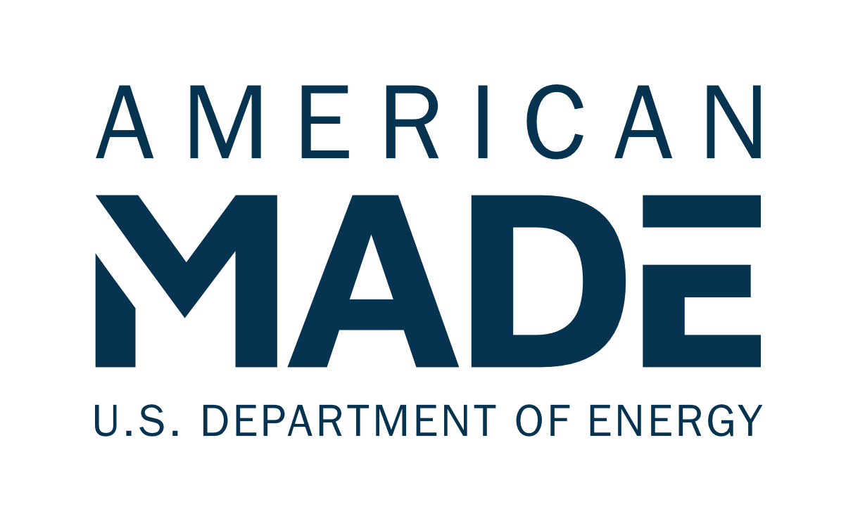

**Electronics Scrap Recycling   
Advancement Prize (E-SCRAP)  
Phase 1: Incubate Narrative Template**

# Team Name: (Team Name)

# Four Question Written Narrative Instructions

Answer each of the following four questions:

1. **Innovation** – What is your innovation and why will it be impactful?
2. **Value Chain Insight and Opportunity** – How does your innovation integrate into the recycling value chain?
3. **Accomplishments and Team** – Does your team have the knowledge and experience to be successful? What have you accomplished to date?
4. **Plan** – What is your plan to implement the innovation?

For convenience, these questions are provided in the headings of the tables on pages 2-9 along with suggested content (and corresponding judging statements) to help guide your responses. You decide where to focus your answers.

You should answer each of the following four questions listed below. The content bullets are only suggestions to guide your responses. You decide where to focus your answers. The individual answers to the four questions do not have a word limit; however, **the aggregate response to these four questions must not exceed 2,500 words,** not including captions, figures/graphs, and references. A word count must be included at the end of your submission. You may also include **up to five supporting images, figures, or graphs**. The reviewers will score the questions based on the content you have provided. The narrative should be submitted as a PDF file.

|  |  |  |
| --- | --- | --- |
| **Topic and Percent of Score** | **Suggested Content to Include** | **What the Score Will Be Based On** |
| **Question 1:**  ***Innovation***  What is your innovation and why will it be impactful?  This section is 25% weight of your total score. | * Describe the innovation, its value proposition, and how it will deliver an expansion of critical materials recovered from e-scrap. * Describe how your innovation improves on the status quo from an environmental impact standpoint while maintaining economic competitiveness using evidence-based validation (e.g., product-market fit, interviews, case studies, literature). * Describe how you will leverage opportunities to continue advancing your innovation to improve beyond its current status by using metrics and the expected capacity. * Indicate how your innovation can expand or establish the recovery of critical materials from e-scrap. Where possible, indicate the potential to recover multiple critical materials and noncritical material co-products. * Describe challenges with e-scrap recycling that can impact disadvantaged, underserved, and/or marginalized communities and the benefit your proposed innovation will reduce or eliminate the issues. | * The competitor identifies an innovation that advances the recovery of critical materials from e-scrap and provides a clear value proposition. A considerable amount of high-quality effort was put into defining the opportunity and advancing the innovation concept. * The competitor comprehensively describes the innovation’s expected impacts (economic competitiveness and/or life-cycle impact of critical materials recovery) beyond the status quo. * The competitor provides a compelling case for how the innovation will continue to advance beyond its current state through feedstock processing and validation, improved performance (e.g. yield, life cycle impacts, concentration), and capacity growth. Competitor provides an example that demonstrates how their innovation moves beyond the existing technology. * The competitor indicates the potential to produce multiple streams of critical materials and/or noncritical coproducts from identified feedstock(s). * The competitor demonstrates insight into the impact e-scrap recycling can have on disadvantaged, underserved, and/or marginalized communities. This includes environmental and economic benefits, hazards, and workforce implications. |

**Response to Question 1:**

|  |  |  |
| --- | --- | --- |
| **Topic and Percent of Score** | **Suggested Content to Include** | **What the Score Will Be Based On** |
| **Question 2:**  ***Value Chain Insight and Opportunity***  How does your innovation integrate into the recycling value chain?  This section is 25% weight of your total score. | * Explain why the opportunity has not yet been realized and why now is the right time to address it. * Detail how your innovation enables the optimization and/or integration of critical material separation technologies into the complete recycling value chain, particularly between end-of-life and reintroduction phases. Explain the ripple effects and impacts on other stakeholders within the recycling value chain due to your innovation, emphasizing environmental and economic viability improvements in the supply chain. * Provide details on anticipated challenges to successfully realizing the recycling value chain opportunity and how this innovation can overcome these challenges. * Highlight existing information gaps within the recycling value chain and explain how your strategy involves partnerships and engagement will address them. * Describe the inputs and outputs based on your role in the recycling value chain and how you will engage with entities upstream and downstream from your operations to optimize the economics and life cycle impacts of recycling. | * The competitor demonstrates an understanding of the opportunity, why it has not yet been realized, and why now is the right time to address it. * The competitor identifies and clearly explains an opportunity to expand capacity for critical materials recovered from e-scrap that, if realized, will deliver substantial environmental and economic benefits. * The competitor demonstrates insight into the full recycling value chain (waste stream, processes needed, end markets) and provides estimates of expected impacts based on reasonable assumptions. * The competitor describes the approach to utilize partnerships and engagement across the recycling value chain to close existing information gaps by optimizing and integrating the innovation. * The competitor provides comprehensive detail on the inputs and outputs relevant to the innovation’s role within the recycling value chain and provides proactive strategies for engaging with entities upstream and downstream. |

**Response to Question 2:**

|  |  |  |
| --- | --- | --- |
| **Topic and Percent of Score** | **Suggested Content to Include** | **What the Score Will Be Based On** |
| **Question 3:**  ***Accomplishments and Team***  Does your team have the knowledge and experience to be successful? What have you accomplished to date?  This section is 20% weight of your total score. | * Introduce your team and describe the team makeup. Highlight knowledge, experience, and skills that make your team capable of realizing the innovation. * Describe your team’s readiness to meet your goals and whether your team requires additional talent and/or resources. Identify any potential gaps and how the team will overcome them. * What partnerships does your team currently have and what partnerships does your team still need to form to be successful? * Indicate representation of organizations across the recycling value chain through partnerships, agreements, and connections that facilitate material flow and information sharing. This can include collection, sorting, separation, recovery, refining, and validation of materials. | * The team is diverse and has the knowledge, experience, and skills to realize the innovation. * The team has identified any relevant gaps in resources to be addressed. * The team demonstrates a comprehensive network of partnerships or affiliations across the recycling value chain relevant to the innovation and the team clearly outlines how they will engage partnerships that are currently lacking. * The team spans multiple stages of the recycling value chain to inform optimization and off-takes that validate innovative approaches to establishing and expanding critical material production from e-scrap. |

**Response to Question 3:**

|  |  |  |
| --- | --- | --- |
| **Topic and Percent of Score** | **Suggested Content to Include** | **What the Score Will Be Based On** |
| **Question 4:**  ***Plan***  What is your plan to implement the innovation?  This section is 20% weight of your total score. | * Describe where you stand in your innovation’s development cycle and develop a plan with SMART[1] goals to advance your innovation from the current state toward implementation in a viable supply chain. * Describe your team’s proposed metrics that will be used to determine success. * Describe risks and mitigation strategies to your innovation and how you will address them. * Demonstrate an understanding of the adoption readiness levels and indicate adoption risks of the technology and how you plan to decrease those risks.[2] * How will you leverage analysis support in Phase 2 from a national lab?   + Describe any analysis that has done been previously. * Describe how you will validate the continued advancement of your technology or process. * Describe the specific strategies and activities that you plan to use to engage, educate, gain trust, and obtain buy-in from disadvantaged, underserved, and/or marginalized communities. | * The stated goals are ambitious and show commitment to an accelerated development timeline. Meeting them will demonstrate critical progress toward implementing the innovation. * The proposed metrics are clear, well defined, and enable actionable steps toward progressing the optimization, validation, and integration of the technology or process. * The competitor showcases proactive risk management with effective and viable strategies to mitigate identified risks. * The competitor demonstrates an understanding of the core risk areas facing adoption readiness and outlines a plan to decrease those risks. * The competitor clearly outlines past analysis experiences and their relevance in demonstrating the team's capability to effectively utilize the support. * The competitor indicates what they aim to learn from the analysis consultation with a national lab and how the analysis will help them gain insights to inform design improvements, increasing the innovation’s impact in a viable supply chain. * The approach to engage disadvantaged, underserved, and/or marginalized communities describes at least one measurable goal with concrete actions and is likely to be successful. |

**Response to Question 4:**

## Four question narrative word count: _______ total words

**Please read and comply with submission requirements in the** [**Official Rules**](https://www.herox.com/ESCRAP-Prize/resource/1667)**.**

**COMPETITORS THAT DO NOT COMPLY WITH THESE REQUIREMENTS MAY BE DISQUALIFIED.**

1. A SMART action plan incorporates five characteristics of a goal: specific, measurable, attainable, relevant, and time-based. For more information about SMART goal planning, see: <https://www.atlassian.com/blog/productivity/how-to-write-smart-goals>.
2. [Adoption Readiness Levels (ARL): A Complement to TRL | Department of Energy](https://www.energy.gov/technologytransitions/adoption-readiness-levels-arl-complement-trl)