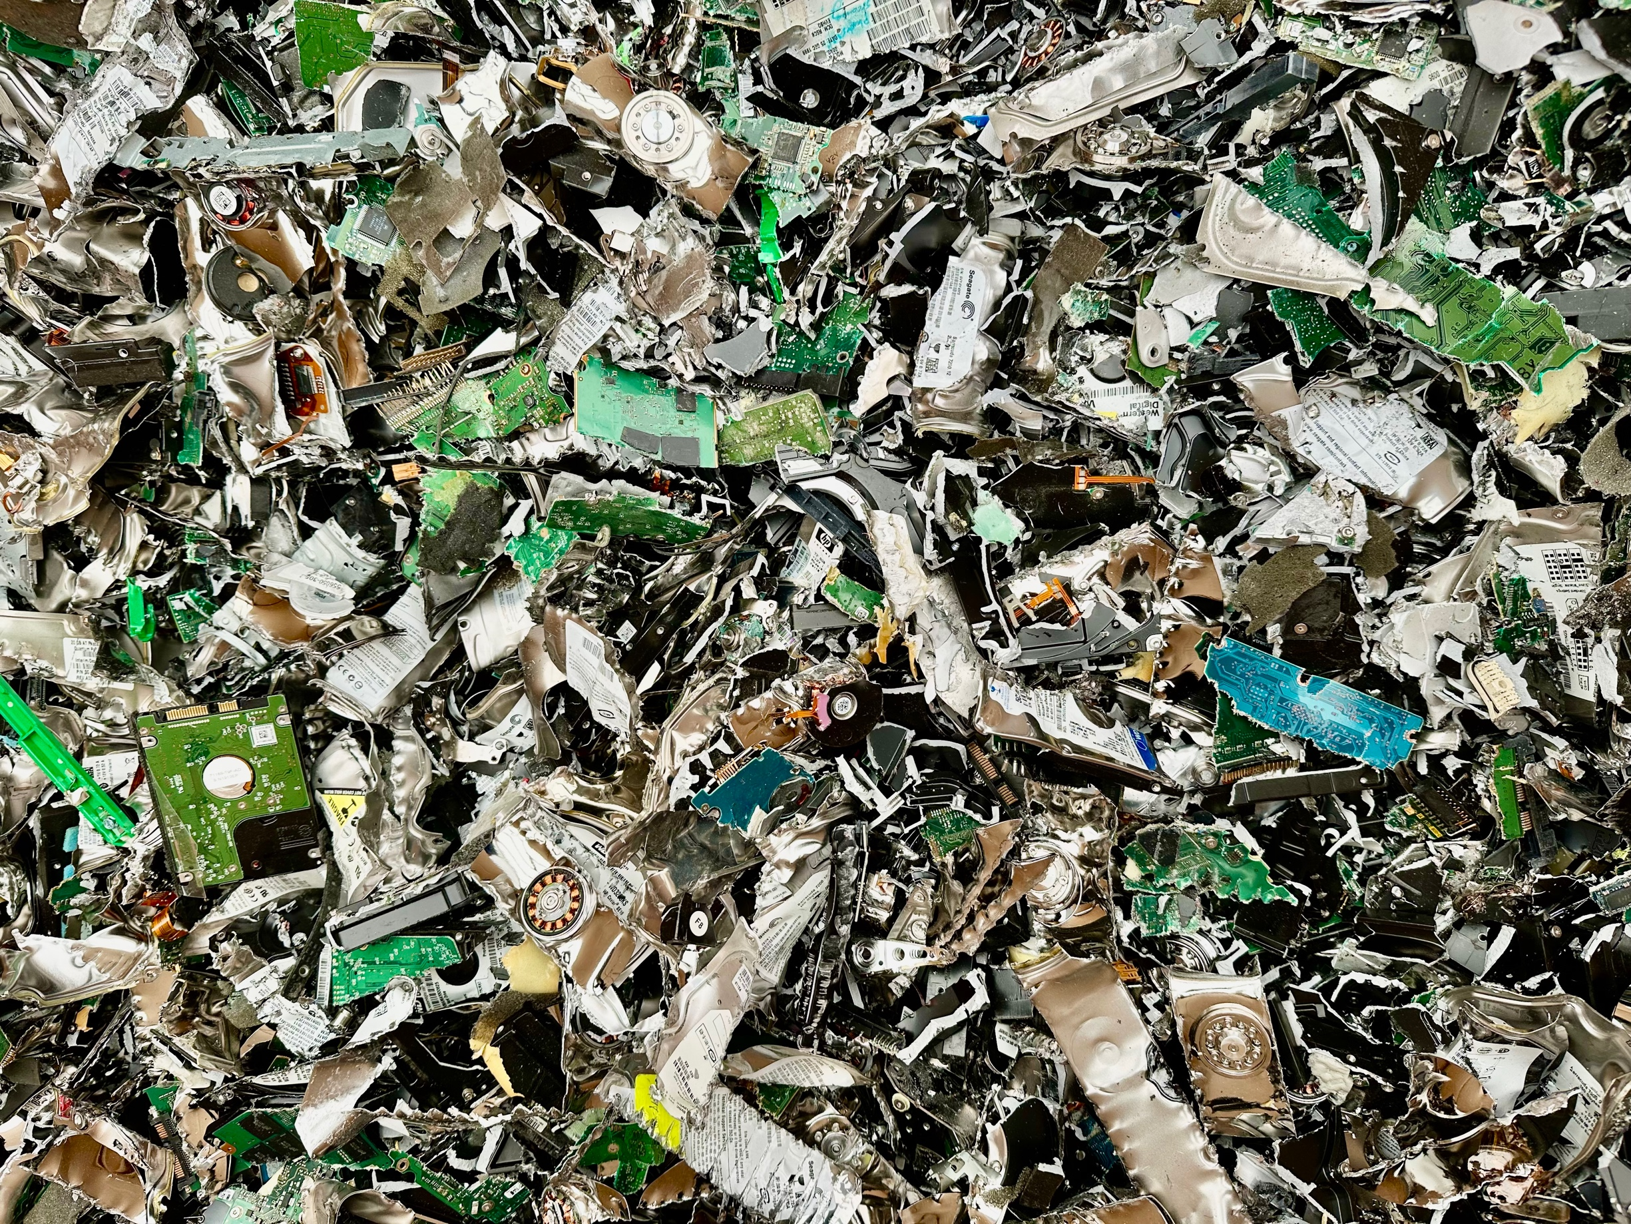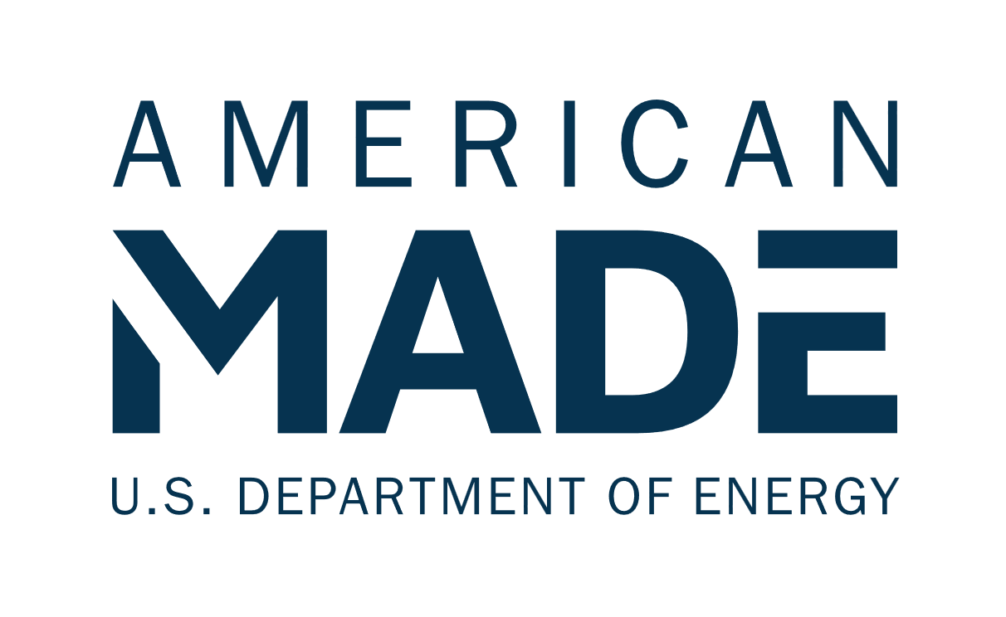

**Electronics Scrap Recycling   
Advancement Prize (E-SCRAP)  
Phase 2: Prototype Narrative Template**

# Team Name: (Team Name)

# Five Question Written Narrative Instructions

Answer each of the following five questions:

1. **Innovation Advancement** – How has your innovation progressed towards implementation?
2. **Value Chain Coordination** – What partnerships have been made and how will they be leveraged?
3. **Data and Analysis** – How are you generating needed data for analysis and how will these insights advance the innovation?
4. **Value Chain Integration** – How is the innovation optimized to connect with upstream and downstream partners?
5. **Plan** – How will you engage across the recycling value chain and advance your innovation in an informed way?

For convenience, these questions are provided in the headings of the tables on pages 2-11 along with suggested content (and corresponding judging statements) to help guide your responses. You decide where to focus your answers.

You should answer each of the following five questions listed below. The content bullets are only suggestions to guide your responses. You decide where to focus your answers. The individual answers to the five questions do not have a word limit; however, **the aggregate response to these five questions must not exceed 5,000 words,** not including captions, figures/graphs, and references. A word count must be included at the end of your submission. You may also include **up to five supporting images, figures, or graphs**. The reviewers will score the questions based on the content you have provided. The narrative should be submitted as a PDF file.

|  |  |  |
| --- | --- | --- |
| **Topic and Percent of Score** | **Suggested Content to Include** | **What the Score Will Be Based On** |
| **Question 1:**  ***Innovation Advancement***  How has your innovation progressed toward implementation?  This section is 20% weight of your total score. | * Describe your innovation, its value proposition, and how it will deliver critical materials capacity expansion with improved economic/environment impacts relative to the status quo. Explain how the development and maturity of the innovation has evolved over the course of the prize. * Indicate how the critical materials produced compare (in quality, volume, price, life cycle impacts) to critical materials currently in the marketplace. * Describe anticipated challenges to validating the value and performance of the innovation and how the challenges can be overcome. * Provide estimates of e-scrap feedstock availability and the potential critical materials yield and capacity. Where possible, indicate the flexibility of your innovation to recover multiple critical materials from a variety of feedstocks. * Describe how you will optimize the recovery process from the identified feedstock, considering factors such as availability, capacity, and efficiency, to ensure effective extraction of critical materials from e-scrap? * Indicate how the recovery of critical materials is run in parallel or in sequence with the recovery of noncritical materials as value-added coproducts. * Describe the impact of your innovation and recycling value chain on disadvantaged, underserved, and/or marginalized communities and how your understanding has evolved over the prize. | * The competitor demonstrates the economic and environmental significance of the innovation and exhibits progress toward validating the benefits of the innovation, including, in particular, its ability to facilitate an increased critical materials production capacity from e-scrap. * The competitor provides initial indication of the quality and purity of critical materials recovered compared to current critical materials markets. Plans to validate the material quality and purity of critical materials recovered through collaboration with a national laboratory should be outlined in question 4, “Plan.” * The competitor should demonstrate the repeatability and consistency of material quality and purity. Plans to improve shortfalls in quality, purity and repeatability should be addressed in question 4, “Plan.” * The competitor indicates the potential to produce multiple streams of critical materials from an identified feedstock. * The competitor has identified at least one feedstock that will serve as a test case for recovering critical materials. They have established access to the feedstock and indicated its availability and capacity to produce critical materials from e-scrap. * The competitor identifies the value added through recovery of coproducts (critical materials or noncritical materials) and how each contribute to one another. The recovery of multiple critical materials should be prioritized. * The competitor demonstrates deepening insight into the impact of the proposed recycling value chain on disadvantaged, underserved, and/or marginalized communities. |

**Response to Question 1:**

|  |  |  |
| --- | --- | --- |
| **Topic and Percent of Score** | **Suggested Content to Include** | **What the Score Will Be Based On** |
| **Question 2:**  ***Value Chain Coordination***  What partnerships have been made and how will they be leveraged?  This section is 20% weight of your total score. | * Describe how you have engaged entities across the recycling value chain to share information about input and output requirements and how you will use that collaboration to optimize the technoeconomic performance of the critical materials recycling value chain. Indicate what you will learn from these partnerships. * Exhibit knowledge (source, composition, cost, location, capacity) of current input feedstocks and indicate how your process or technology will facilitate the recovery of critical materials from the input feedstock. Comment on the type and amount of e-scrap included in the feedstock and the expected critical materials yield. * Describe what the outputs of your process or technology are and how the key performance metrics compare to the requirements by entities downstream. * Address the economic viability of the recycling value chain including the influence of coproduction of noncritical materials outputs. | * The competitor demonstrates knowledge of the full e-scrap recycling value chain and which entities the outputs and inputs of their process/technology are directed to and from. The competitor also demonstrates knowledge of the metrics that drive the neighboring entities’ economic and technological success. * The competitor demonstrates connections across the recycling value chain and a plan to exchange and utilize to inform process or technology optimization. * The competitor addresses the viability of the recycling value chain to accommodate the co-production of one or more critical materials and co-production of non-critical materials. * The competitor identifies potential customers and the critical (and byproduct) material characteristics (structure, composition, price, etc.) to serve as a benchmark for the material produced through recovery from e-scrap. |

**Response to Question 2:**

|  |  |  |
| --- | --- | --- |
| **Topic and Percent of Score** | **Suggested Content to Include** | **What the Score Will Be Based On** |
| **Question 3:**  ***Data and Analysis***  How are you generating needed data for analysis and how will these insights advance the innovation?  This section is 15% weight of your total score. | * Describe the LCA, TEA, or other analysis that a national laboratory will perform during Phase 3 to assess the potential impact of your innovation and opportunities to improve it and/or increase the impact. What insights do you expect to gain and how will you incorporate them into your plan? How have insights from national lab analysis consultation been incorporated into your understanding, if applicable? * Describe what was learned during analysis consultation and how it informs the data collection during Phase 2, if relevant. * Describe what characterization and data collection will be performed to inform LCA and TEA by a national lab in Phase 3. * Describe how you will evaluate & collect data on characteristics that drive the economics/environmental aspects, such as your LCA/TEA work.   + How does all of this produce critical materials? * Describe how LCA and TEA metrics inform technology adoption risks and chart a path to reduce those risks (adoption risks include: value proposition, market acceptance, resource maturity, and license to operate).[1] * Describe how LCA metrics can assess your innovation’s impact on disadvantaged, underserved, and/or marginalized communities | * The team describes what insights the national lab or other analysis provided and how it will be used to improve their innovation and increase impact. The proposed analysis makes sense, is likely to provide insights to improve their innovation and impact, and the competitor is poised to incorporate those insights into future plans. * The competitor demonstrates a plan to gather relevant information that informs technology or process optimization during prototyping and demonstration. * The competitor details a comprehensive plan for data collection and characterization specifically tailored to inform LCA and TEA and has strategies to ensure high-quality data collection for accurate assessment of economic and environmental impact. * The competitor indicates the adoption readiness level of their technology or process and outlines how data collected through TEA, LCA, or other analysis will empower them to reduce adoption risks. * Indicates metrics that will be collected to understand impact of technology or process on disadvantaged, underserved, or marginalized communities. |

**Response to Question 3:**

|  |  |  |
| --- | --- | --- |
| **Topic and Percent of Score** | **Suggested Content to Include** | **What the Score Will Be Based On** |
| **Question 4:**  ***Value Chain Integration***  How is the innovation optimized to connect with upstream and downstream partners?  This section is 20% weight of your total score. | * What are the partnerships that will allow you to integrate your innovation into existing and new recycling value chains? * What value does your innovation offer to these potential partners within existing or new recycling value chains? How does it align with their objectives or enhance their operations? * Describe how progress made throughout the prize actively decreases project risks and adoption risks (value proposition, market acceptance, resource maturity, and license to operate). * How will you ensure continuous collaboration and alignment of goals with these partners for a long-term partnership? * What strategies are in place to optimize outputs to specifically meet the needs or requirements of downstream partners? * How will you incorporate feedback from both upstream and downstream partners to continuously improve or adapt? Do you have processes in place for gathering and implementing this feedback? | * The competitor demonstrates their ability to improve economic and environmental benefits of the innovation. This includes working with a partner organization to optimize inputs/feedstock or to optimize outputs to meet downstream partner needs/requirements. * The competitor illustrates how the innovation aligns the goals of partners, showcasing mutual benefits. * The competitor assesses and reports progress toward enhancing adoption readiness. The commercial adoption readiness tool can be used. * The competitor outlines measures to ensure continuous collaboration and engagement with partners. * The competitor has established clearly defined processes for gathering feedback from both upstream and downstream partners. * The competitor identifies and engages with customers who will offtake the produced critical materials. Special emphasis will be placed on purchasing agreements or commitments. |

**Response to Question 4:**

|  |  |  |
| --- | --- | --- |
| **Topic and Percent of Score** | **Suggested Content to Include** | **What the Score Will Be Based On** |
| **Question 5:**  ***Plan***  How will you engage across the recycling value chain and advance your innovation in an informed way?  This section is 15% weight of your total score. | * Provide a detailed plan with SMART goals for advancing your innovation from the current state toward implementation in a viable e-scrap recycling value chain. Competitors can revise their previous plan. Include metrics that will be used to determine success. * Describe the risks to the plan to advance your innovation and mitigation strategies to address them. * Identify upstream or downstream optimization that can occur by cooperating with recycling value chain partners to improve the efficiency of your process/technology. * Describe your team’s capability, expertise, and resources to execute the proposed activities and meet the goals. * How do you intend to effectively measure material quality, purity, and price against relevant benchmarks in the dynamic critical materials marketplace? * Describe progress made in engaging, educating, gaining trust, or obtaining buy-in from disadvantaged, underserved, and/or marginalized communities. Include challenges or barriers identified and how you plan to continue to engage these communities. | * The stated goals are ambitious, address risks, and show commitment to an accelerated implementation timeline. Meeting the stated goals will demonstrate critical progress toward implementing the innovation into a viable e-scrap recycling value chain. * The competitor identifies potential risks and has identified appropriate mitigation actions to minimize them. * The competitor demonstrates an understanding of what performance levels and coordination are needed to integrate the innovation into a new or existing e-scrap recycling value chain and maximize recovered critical materials output in economically viable way with minimized environmental impact. * The team demonstrates the knowledge and ability to properly execute their proposed activities while meeting their specified goals. * The competitor outlines a plan to identify key performance metrics in collaboration with potential off-take partners. * The competitor outlines a plan to collaborate with a National Lab in Phase 3 to validate key performance metrics and compare them to the status quo. * The competitor outlines a plan to collaborate with potential off-take partners to assess the price of produced materials and compare results to benchmarks in the current critical materials marketplace. * The approach to community engagement describes concrete actions, is strong, and demonstrates progress. |

**Response to Question 5:**

## Five question narrative word count: _______ total words

**Please read and comply with submission requirements in the** [**Official Rules**](https://www.herox.com/ESCRAP-Prize/resource/1667)**.**

**COMPETITORS THAT DO NOT COMPLY WITH THESE REQUIREMENTS MAY BE DISQUALIFIED.**

1. [Adoption Readiness Levels (ARL): A Complement to TRL | Department of Energy](https://www.energy.gov/technologytransitions/adoption-readiness-levels-arl-complement-trl)