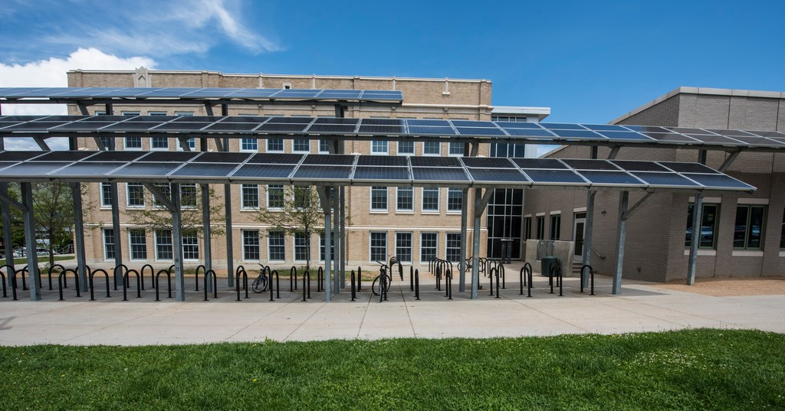

Figure 1

**[Title]**

[Local Educational Agency]

[First Author, Second Author, and Third Author]

[Month Year]

DELETE BLUE ITALICIZED TEXT BEFORE SUBMISSION.

# *Instructions*

*DOE is providing this template as an administrative convenience for Local Education Agencies (LEAs). Use of this template is not required.*

*Blue italicized text is instructional and should be deleted before submission. This document should include no more than 2,500 words (roughly 5 pages). LEAs may include one attachment per prioritized school, but please ensure all attachments are combined with the main Planning Document and submitted as a single PDF for submission.*

*As described in the rules, LEAs are asked to “Provide a single easy-to-read planning document – comprehensive of the entire LEA – summarizing the top priorities to upgrade, update, or transform your school facility/facilities. You may choose to highlight the top schools you plan to address, but please ensure your planning narrative incorporates the entire LEA and/or School District. This Planning Document should complement your Presentation by offering additional detailed information beyond what is provided in the Presentation.”*

Background

This is a planning document for the entire LEA that explains the top priorities to upgrade, update, or transform their school facility/facilities. *Add additional background information as desired.*

# Team Description

*Include LEA information, location, demographics, utilization of trainings, and coaching program.*

# Progress Made During Phase 2 and Associated Impacts

*Describe* *progress made during Phase 2, including energy assessments done, improvements implemented to date, and knowledge gained in Phase 2 that was shared with LEA leadership or other stakeholders so building upgrades are likely to succeed in the future.*

# Summary of Facilities Addressed in this Plan

*Describe* *the facilities addressed in this plan.*

# Summary of Proposed Building Upgrades

*Include a table or list of proposed prioritized upgrades.*

*[Example:]*

|  |  |  |  |  |  |
| --- | --- | --- | --- | --- | --- |
| *Goal* | *Metrics* | *Strategy* | *Action* | *Lead* | *Timeline* |
| *Reduce energy use in LEA buildings by 20% by 2030* | *Electricity use – kwh/yr* | *Upgrade 25% of buildings to Energy STAR levels* | *Benchmark buildings against peers using EPA’s Portfolio Manager* | *Facilities Manager* | *7/31/2024*  *Funded by existing operations budget – No approval needed* |
| *Natural gas use – therms/yr* | *Identify buildings to upgrade in capital planning process* | *Energy Manager* | *10/31/2024*  *Funded by existing operations budget; No approval needed* |
| *Baseline = 2020 kwh/yr & therms/yr* | *Install photovoltaic panels on 25% of buildings* | *Identify all south facing rooftops in building stock* | *Energy Manager* | *Finance by 07/01/2024*  *Start construction by 1/31/2025* |
| *Finance solar through state grant and direct pay* | *Budget project* | *Energy Manager to work with Budget Director* |

# Summary of Impacts

*Identify cost savings and health or learning impacts anticipated if upgrades are implemented.*

# Summary of Next Steps for Implementation

*Describe your strategy for funding or financing the proposed upgrades and your stakeholder/community engagement approach.*