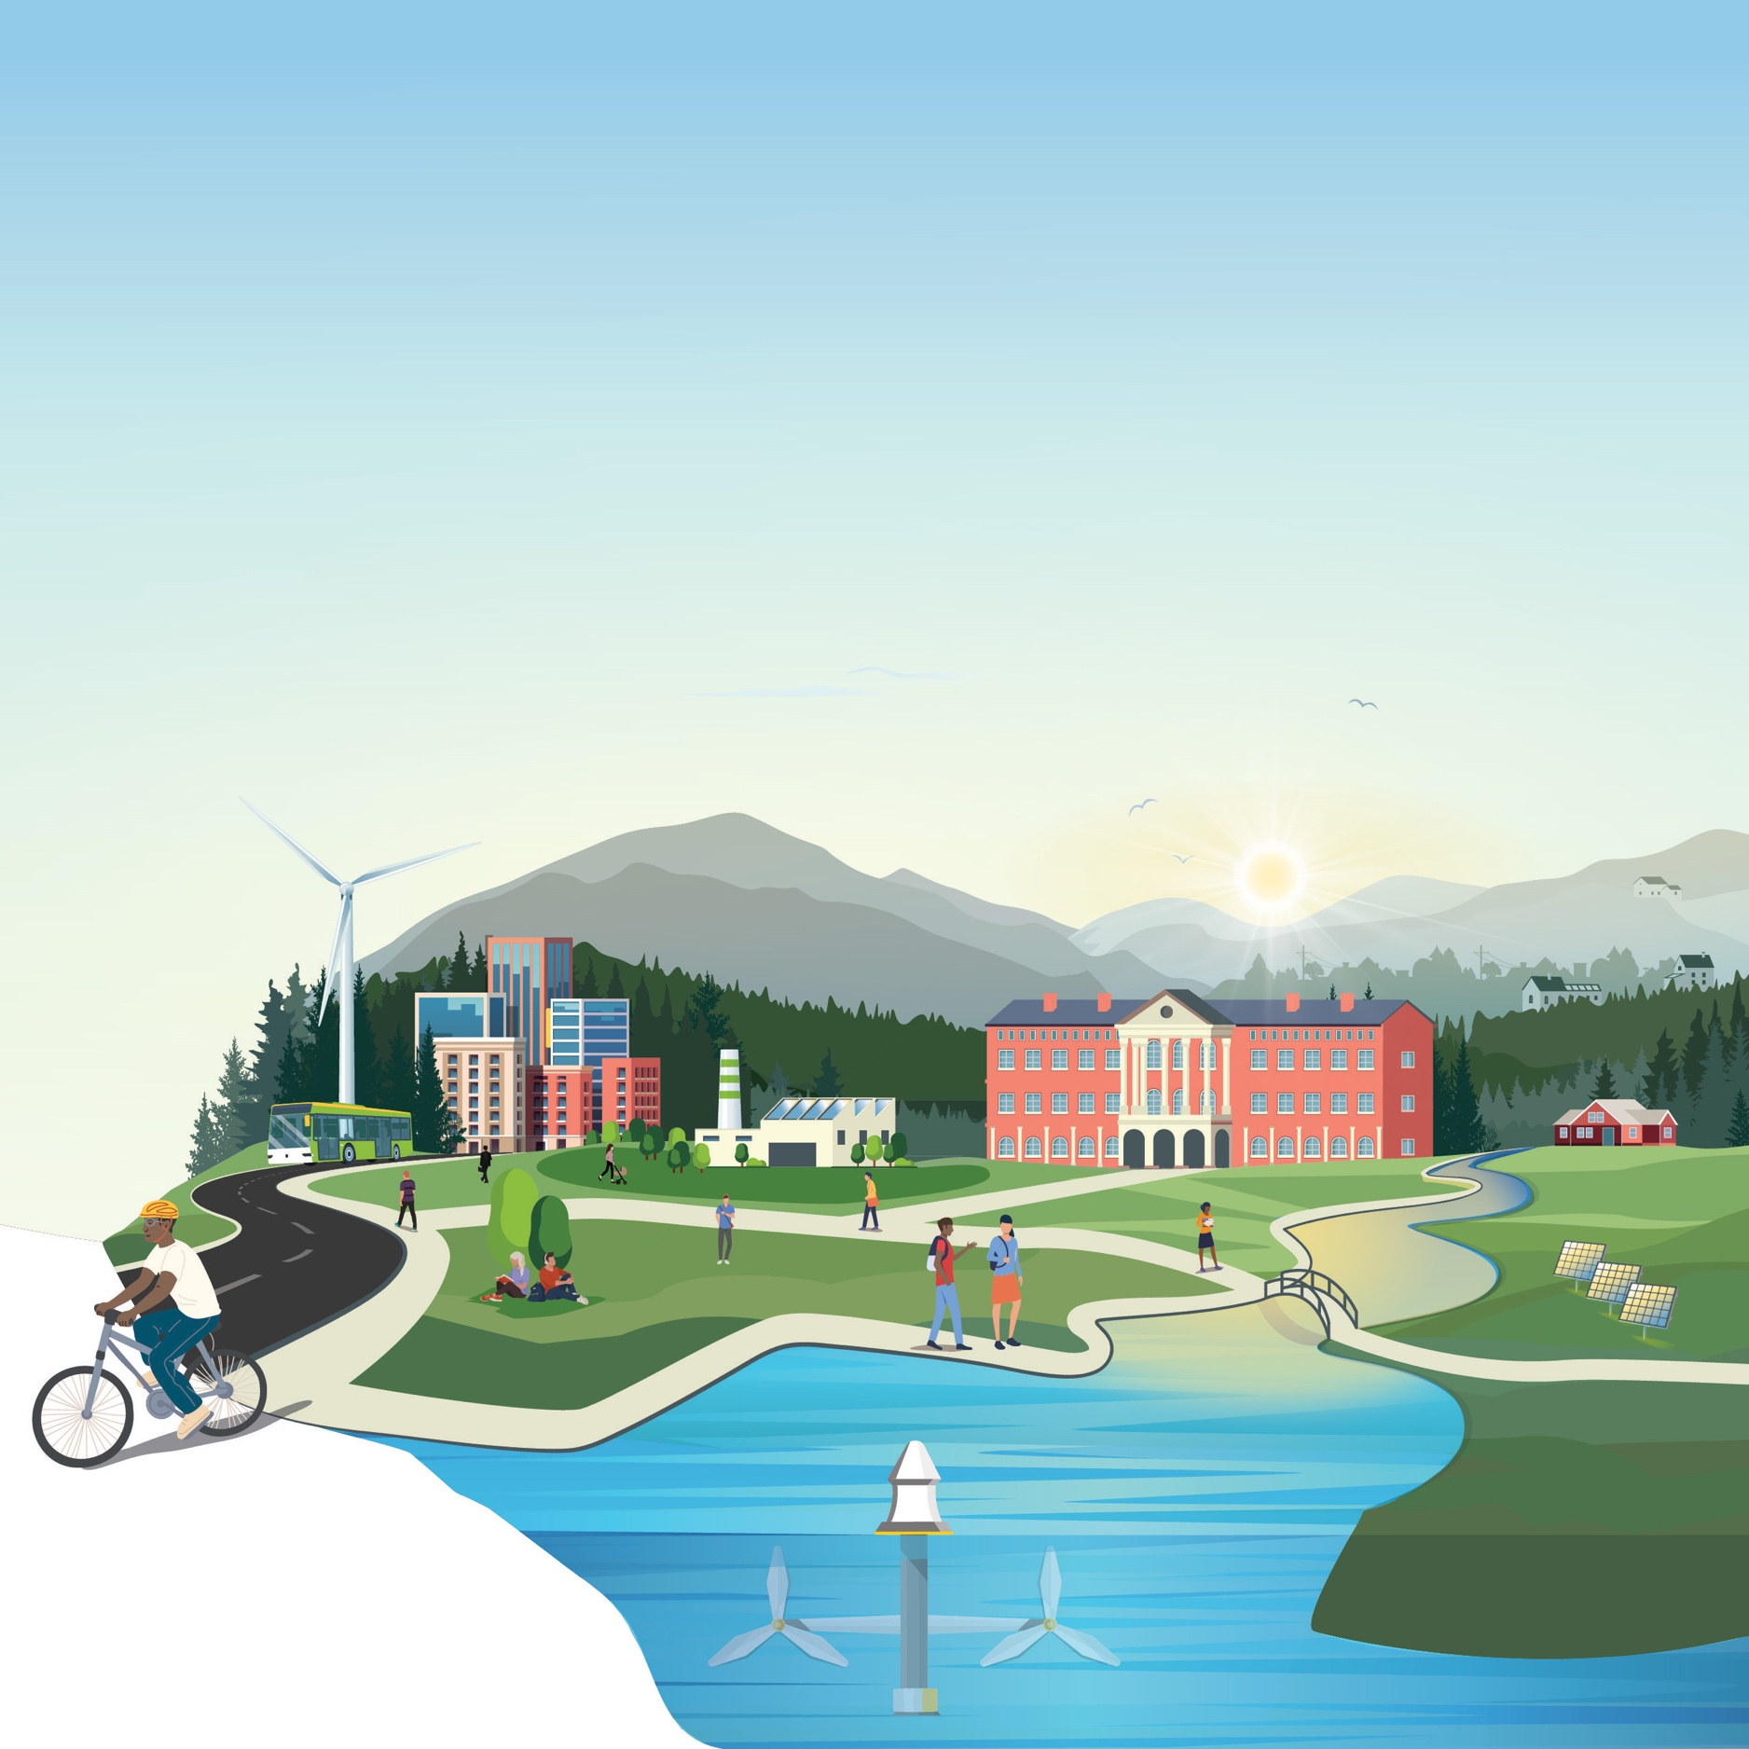
[Official Team Name]
IMPACT Phase – Narrative Document
Community Energy Innovation Prize
Write an Impact Report that details the project implementation, outcomes and accomplishments, and future plans. This submission requirement, along with a final presentation, is intended to act as a capstone for all the work students have accomplished throughout the prize.
The total length of the report should not exceed 5,000 words. Titles, headings, subheadings, footnotes, a short description, and the list of team members/partners do not count toward the 5,000-word limit. Competitors may include up to five supporting visualizations, tables, or graphics. The report must be submitted as a PDF via the HeroX platform, along with the other submission documents. Information contained in hyperlinks to external sources will not be reviewed or considered by the reviewers or the Judge.
Competitors should address the Prize Objectives in Section 2.2 of the Official Rules Document and be guided by the scoring criteria (see Section 3.5.1.2 of the Official Rules Document to see suggested content to provide for these criteria):
- Criterion 1: Project Implementation
- Criterion 2: Community Engagement, Partnerships, and Impact
- Criterion 3: Future Team Priorities
Use of this template is optional.
** PLEASE DELETE THIS TEXTBOX FROM YOUR FINAL SUBMISSION **
[Please delete bracketed guidance text prior to submission]
Contents

1 Team Information 3

2 Short Description 3

3 Narrative Document 3

3.1 Project Implementation 3

3.2 Community Engagement, Partnerships, and Impact 4

3.3 Future Team Priorities 5

1 Team Information
[Fill in the information below for each team member. The first team member listed should be the Team Lead. Does not count towards 5000-word limit.]
Team Lead Name: [first, last] [title/role] [email address]
Team Member 2: [first, last] [title/role] [email address]
Team Member 3: [first, last] [title/role] [email address]
Team Member n: [first, last] [title/role] [email address]

2 Short Description
[A clear and concise description of your team/organization, mission, and the goal of your activity and long-term clean energy project. Recommended length: 50-200 words, does not count towards 5000-word limit.]

3 Narrative Document

3.1 Project Implementation

Suggested content:
- A description of the activities the team has carried out that meet one or more of the goals of the prize stated in Section 2.2.2 of this document.
- A description of how team members were involved in carrying out the activities associated with the prize, including time commitment, number of students and staff, etc.
- A description of resources and strategies the team has utilized to execute their activities, such as how prize awards were used by both the Academic Institution and Community Partner.

3.2 Community Engagement, Partnerships, and Impact

Suggested content:
- A description of how the team has engaged with the relevant disadvantaged community or communities during the Prize alongside a Community Partner.
- A description of how the team has promoted and/or incorporated energy, environmental, and/or climate justice in their activities.
- A description of the community stakeholders the team has engaged throughout the project and how their engagement aided in its success.
- With the appropriate metrics, a detailed description of how the team has successfully met one or more of the goals of this prize aligned with their Community Partner.
- An evaluation of the successes and/or failures in building trusted relationships with disadvantaged communities and plans for incorporating lessons learned into future efforts.

3.3 Future Team Priorities

Suggested content:
- A description of how this experience informed and/or influenced future careers and professional goals of the students on the team.
- A description of the key takeaways from the project experience and how the takeaways informed and/or influenced future organizational priorities and next steps for the Community Partner.

