**PHASE 2: ENGAGE**

*Note: you are not required to use this template. This is an optional guide to help streamline your submission.*

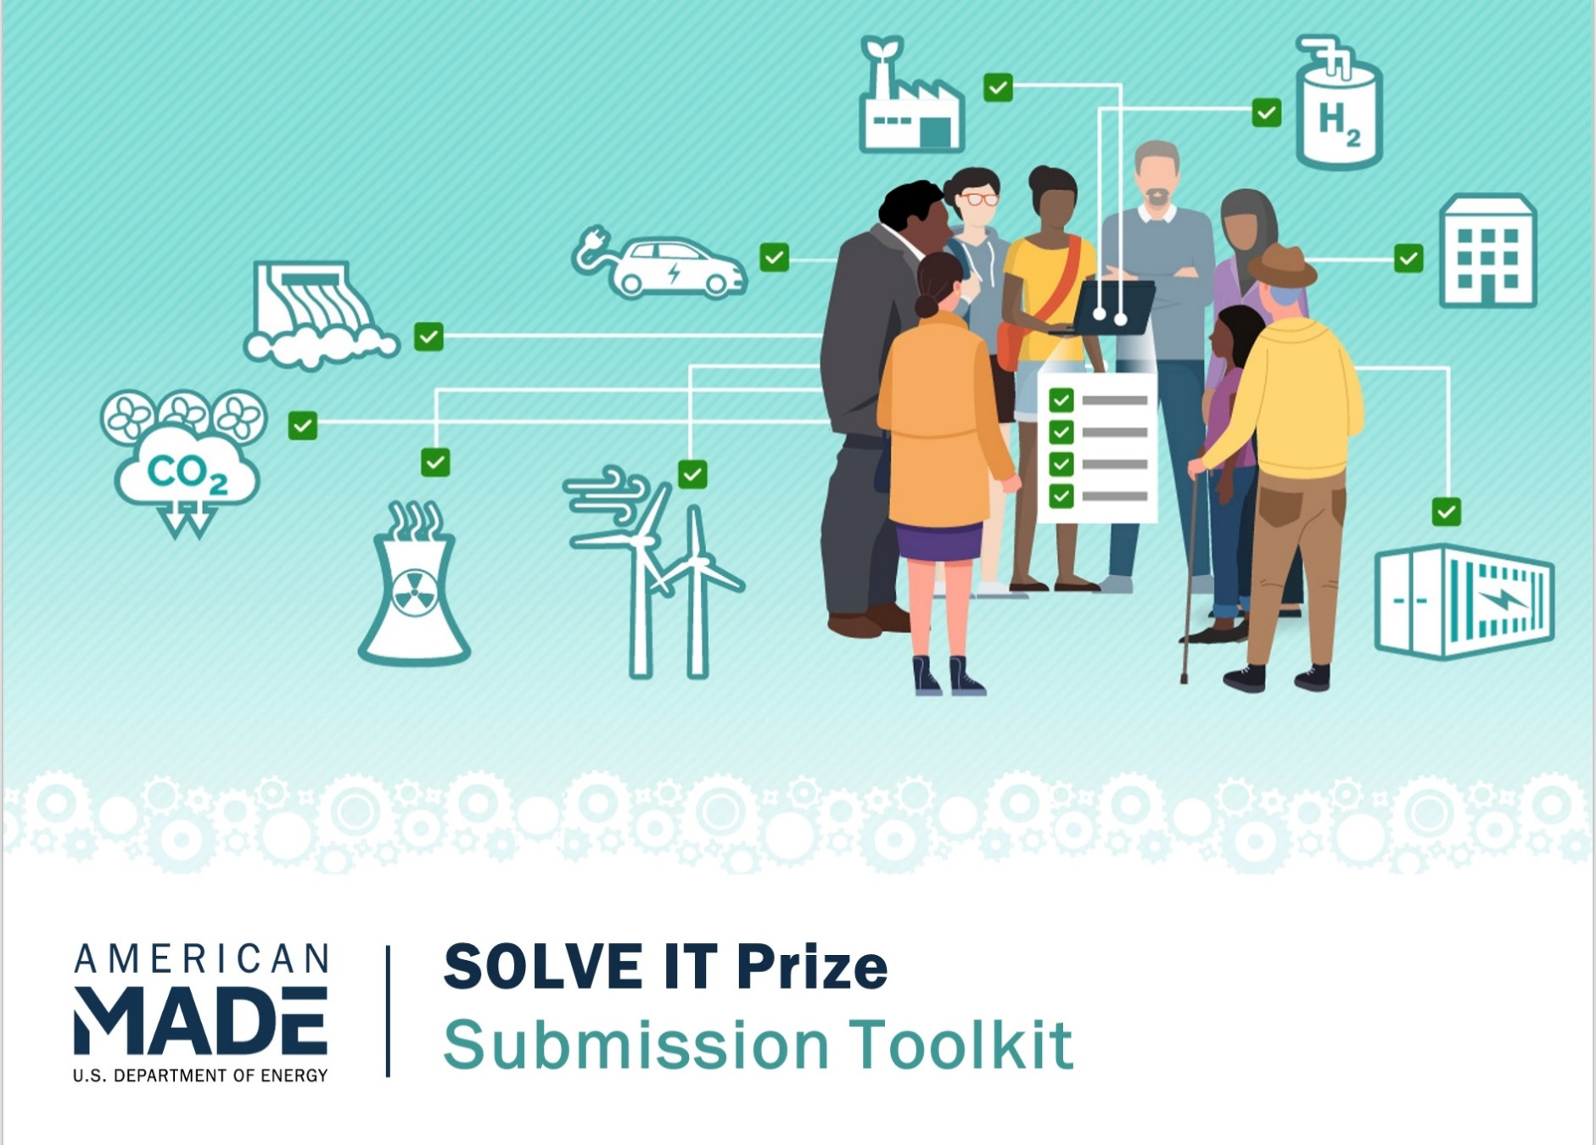**COVER PAGE**

*Please fill out the sections below. You can also design your own cover page—just remember to include all the sections listed below. Please delete all instructional text.*

**SUBMISSION TITLE**

*Recommend keeping the same or similar title as your Phase 1 submission.*

**TEAM NAME**

*Recommend keeping the same or similar title as your Phase 1 submission.*

**TEAM Location**

*City, state, and 9-digit ZIP code*

**SHORT DESCRIPTION OF RESULTS FROM YOUR ENGAGEMENT EFFORTS**

*Please write a short description of the results of your engagement efforts, including high-level metrics (number of engagements, summary of mechanisms, stakeholders engaged).*

**SHORT SUMMARY OF CLEAN ENERGY PROJECT**

*Please write a short summary (1 – 3 sentences)* *of the proposed clean energy or decarbonization project.*

**TEAM MEMBER(S)**

* ***List team lead(s) first:***
  + Name:
  + 9-digit ZIP code:
  + Professional profile (LinkedIn, Facebook, etc.):
* Team member #2 (if applicable):
  + Name:
  + 9-digit ZIP code:
  + Professional profile (LinkedIn, Facebook, etc.):
* Team member #3 (if applicable):
  + Name:
  + 9-digit ZIP code:
  + Professional profile (LinkedIn, Facebook, etc.):
* etc.

**PARTNERS**

*Please list key project partners/organizations. Be sure to include their name, a brief description, and their nine-digit ZIP codes, as well as the organization’s social media handle (if known).*

* [Name of partner/organization]
  + [Insert brief description]
  + [9-digit ZIP code]
* [If there are more partners/organizations, please repeat the above bulleted format.]

**AMERICAN-MADE NETWORK**

*Please list the Power Connector(s) that significantly helped you advance your solution and the major items they helped with (if applicable).*

**SUBMISSION NARRATIVE**

*Submit a written narrative that describes your community engagement efforts, list of community priorities, and selected project. The narrative should not be more than 5,000 words in total and may include up to five tables/figures. Suggested content for the document is below:*

* Briefly describe the team, highlighting key team members and changes since the team’s Phase 1: Embark submission, including new partners.
* Summarize your community engagement effort, including metrics tracked to date.
* Provide a list of the community priorities identified through the engagement process to be addressed through clean energy or decarbonization planning and projects.
* List and describe solutions that can address the listed community priorities and energy challenges.
* Describe the single clean energy or decarbonization project being considered.
* Describe how the project addresses the community’s challenges, meets the priorities of the community as heard in outreach efforts, is technically innovative, and is feasible to be carried out.

**NARRATIVE WORD COUNT: ____________ total words**

**Double check! Do you have a complete Submission Package?**

A complete submission package for Phase 2: Engage should include the following items:

Cover Page

Submission Narrative

Additional Information *(optional)*

*Attach any additional information that demonstrates the success and strength of your engagement effort and proposed solutions. This may include materials that showcase the completed engagement and outreach, additional support for this endeavor, or commitment to solve challenges or find solutions with an energy project.*

Updated Summary Slide *(will be made public)*

*Submit a public-facing, one-slide submission summary that introduces you and your team (if applicable), your community, and your energy-related challenge(s). Any text must be readable in a standard printed page and a conference room projection and should be in at least 14-pt font.*

Please see the [official SOLVE IT Prize rules](https://www.herox.com/SOLVEIT/resource/1644) document for additional submission details and [resources](https://www.herox.com/SOLVEIT/resources).