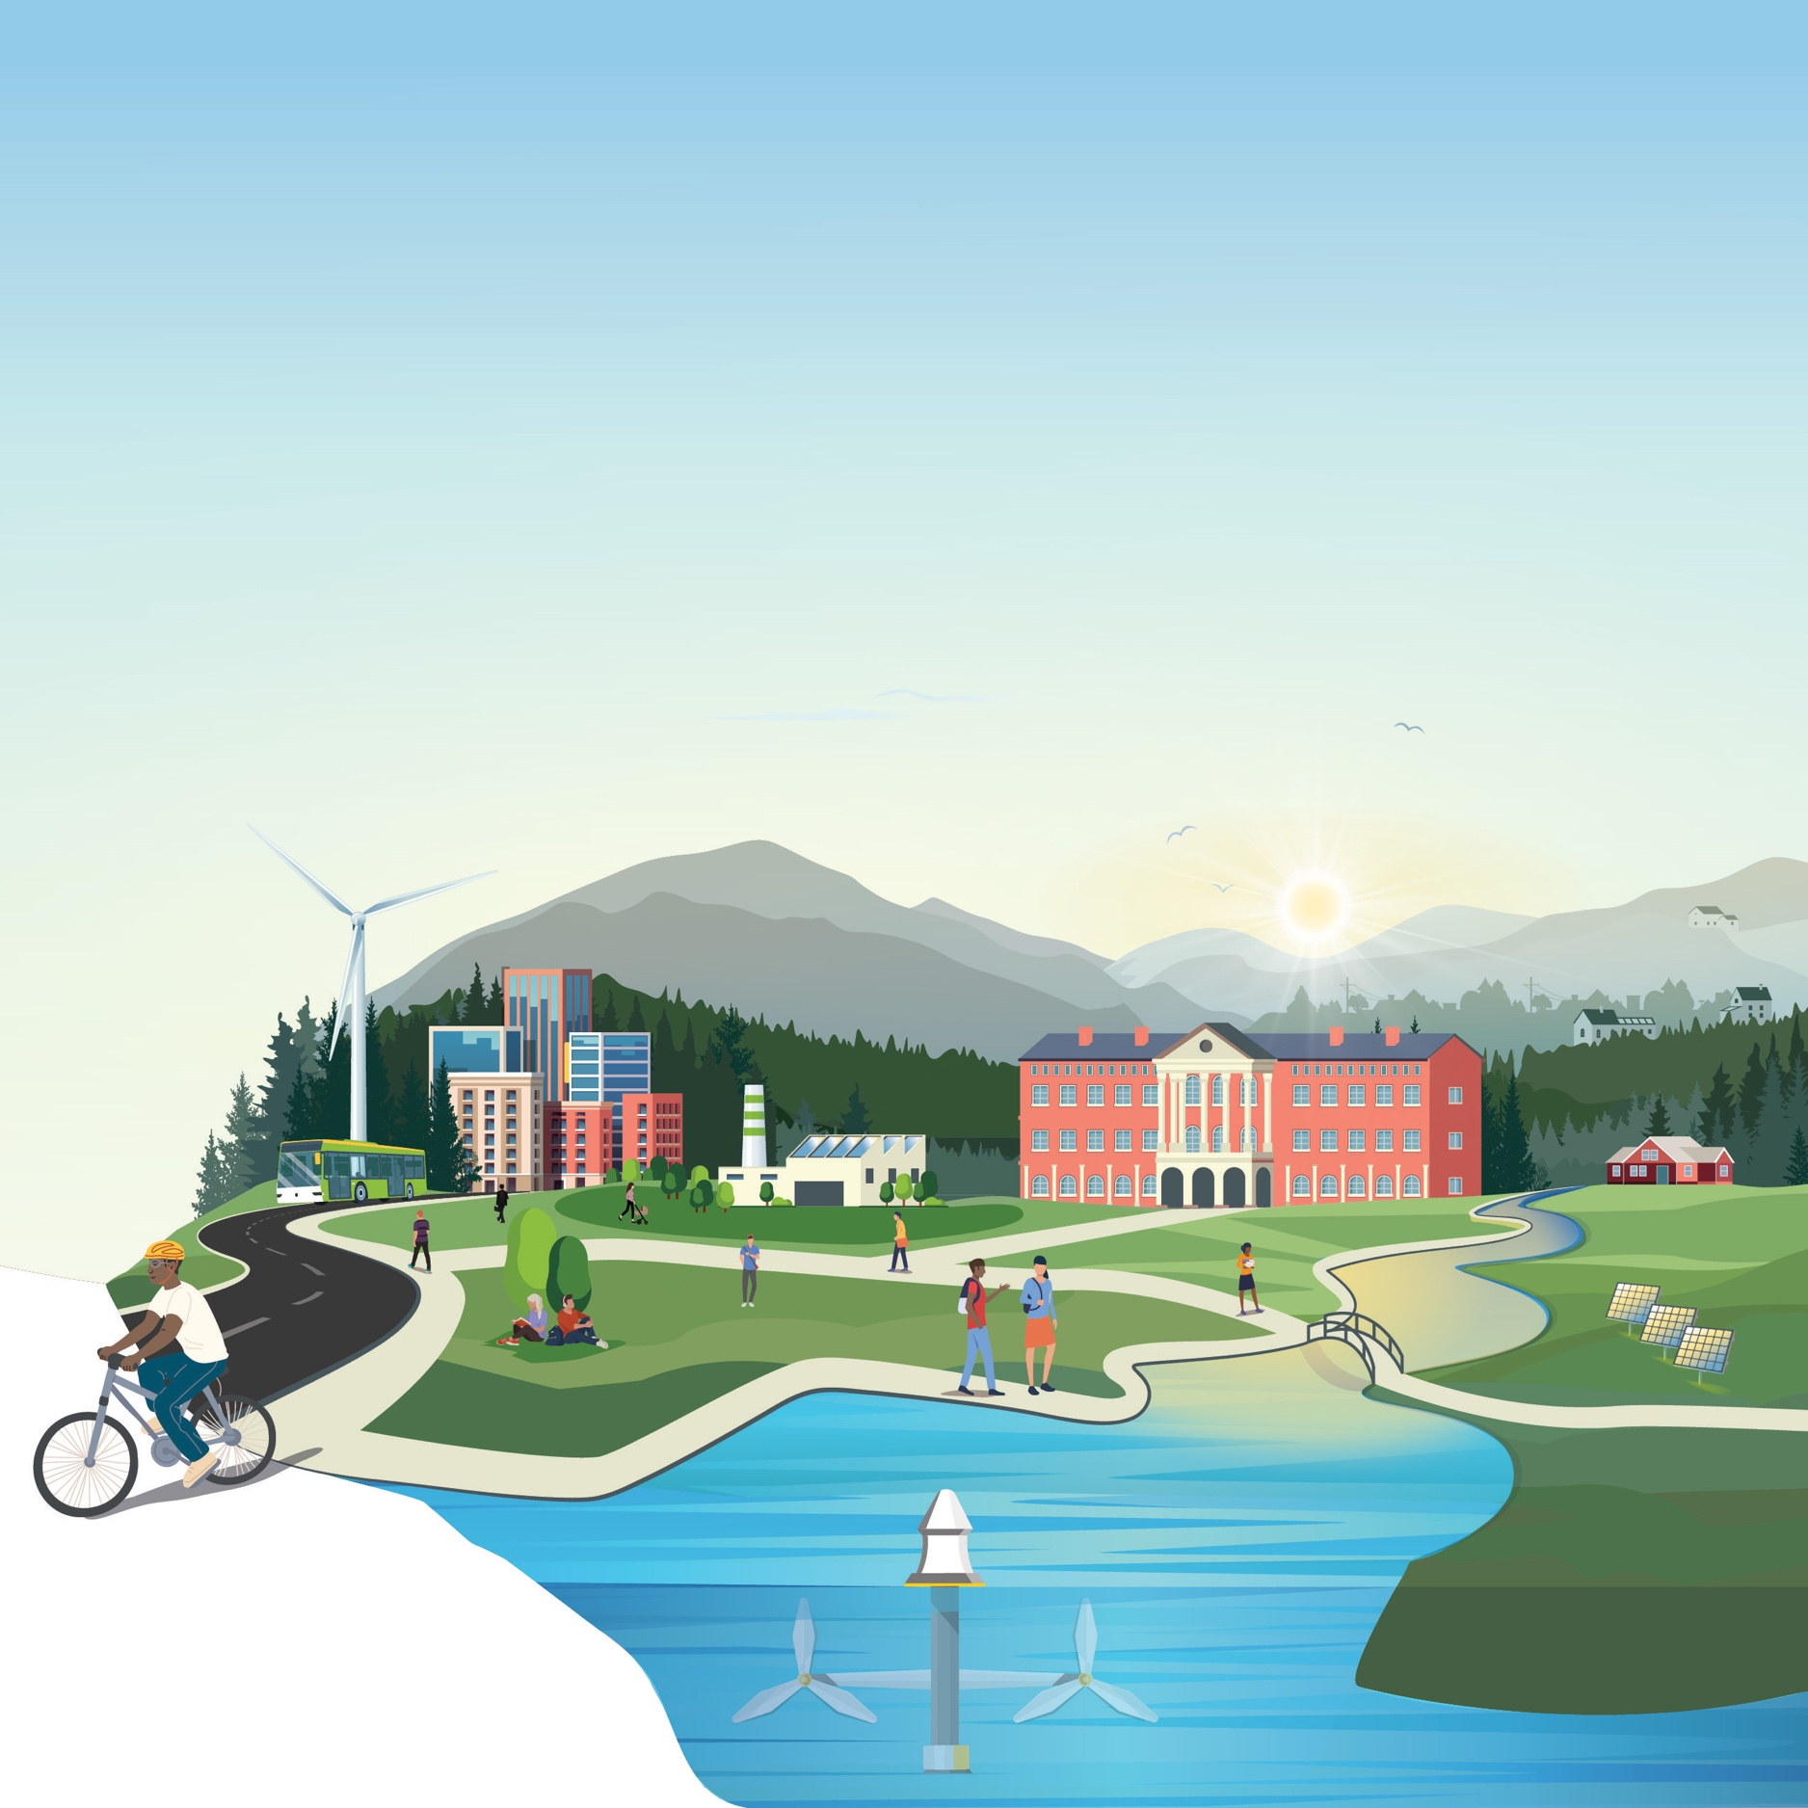
[Official Team Name]
CONCEPT Phase – Impact Plan
Community Energy Innovation Prize
Write a detailed Impact Plan describing the competitor’s responses to all scoring criteria. The initial Impact Plan should describe the competitor’s plans throughout the duration of the prize until the end of the IMPACT Phase and metrics to measure progress toward and success in achieving one or more prize goals.
The total length of the impact plan cannot exceed 5,000 words. This plan may include up to five supporting visualizations or graphics. Information contained in hyperlinks to external sources, and any text or graphics beyond the designated limits, will not be reviewed or considered by reviewers or the judge.
The plan must be submitted as a PDF, via the HeroX platform, along with the other submission documents.
Competitors should address the Prize Objectives in Section 2.2 of the Official Rules Document and be guided by the scoring criteria (see Section 3.4.2 of the Official Rules Document to see suggested content to provide for these criteria):
- Criterion 1: Team and Experience Engaging and Supporting Disadvantaged Communities
- Criterion 2: Proposed Activities and Goals Aligned to the Prize Award
- Criterion 3: Resources and Capabilities to Implement Proposed Activities
Use of this template is optional.
** PLEASE DELETE THIS TEXTBOX FROM YOUR FINAL SUBMISSION **
[Please delete bracketed guidance text prior to submission]

Cover Page
[Include the following information within the cover page.]
- Title.
- Team name.
- Short description. [A clear and concise description of your team/organization, mission, and the goal of your activity and long-term clean energy project.]
- Link to 3-minute online video pitch.
- Key project members and/or partnering organizations (names, contacts, and links to their professional online profiles).
- Location of community to benefit from the clean energy project (name of city, town, or unincorporated area).
- Competitor’s city and state. This may or may not be different than the community to benefit from the clean energy project.
- Goals of the prize the proposed project aims to achieve.
- Prize track that the competitor intends to compete in, i.e., Clean Energy Ecosystem Track or Manufacturing Ecosystem Track.

Impact Plan

Team and Experience Engaging and Supporting Disadvantaged Communities

[Describe your previous experience in engaging and supporting disadvantaged communities, and/or other transferable experience. Include examples of past successes and/or failures which may inform the proposed project plan and activities.
Suggested content:
- An identification of the primary team and partnering organizations and the project roles and responsibilities.
- A description of the experience/expertise of the team in working with disadvantaged communities and promoting clean energy development and in addressing climate change and/or energy justice issues.
- A description of the successes and/or lessons learned of previous efforts engaging and working with disadvantaged communities.
- A description of the community of interest for this prize, and the team’s connection to the community.
- A description of the community’s clean energy needs...]

Proposed Activities and Goals Aligned to the Prize Award
[Describe your project’s planned activities, as well as your project’s goals and how they are aligned to the overall prize award. Include metrics to measure and planned milestones for self-evaluation of progress.
Suggested content:
- A description of how the proposed activities work toward achieving at least one of the prize goals.
- A description of planned activities, metrics to measure, and milestones to complete as specific, measurable, achievable, relevant, and time-bound (SMART) goals.
- A description of credible mechanisms to evaluate the competitor’s progress of activities through the prize.
- An engagement and outreach plan the competitor will use to build trust and strengthen relationships and partnerships with community members and other relevant stakeholders.
- A description of how the proposed project enables a just and equitable transition to a clean energy economy in the relevant community and region...]

Resources and Capabilities to Implement Proposed Activities
[Describe your team’s available resources and capabilities that you plan to leverage for a successful project.
Suggested content:
- A budget for the proposed activities that indicates how the prize funds will be allocated.
- A description of staff resources that will be available to the competitor to achieve the proposed plan, including but not limited to staff experienced in promoting environmental justice, diversity, equity, inclusion, entrepreneurship, and other activities.
- A description of additional staff, partners, resources, and capabilities the competitor seeks to add to carry out their proposed plan and strategies for obtaining....]

